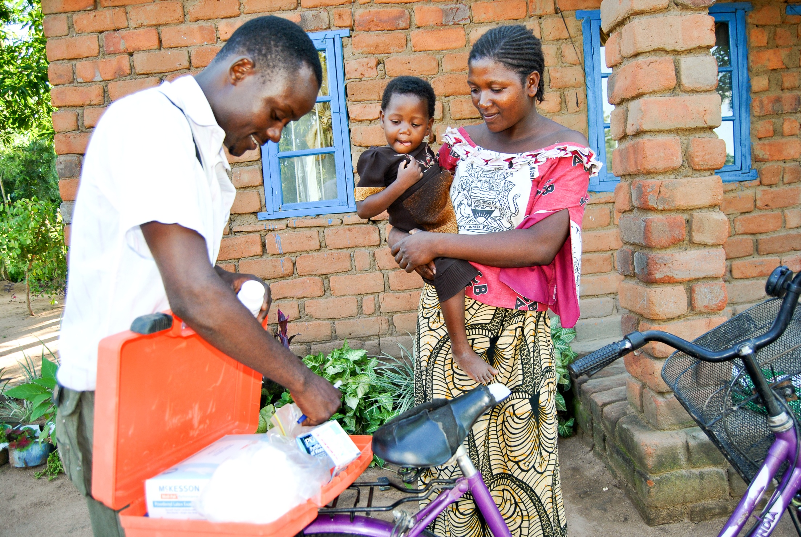
Quality Standards for Design and Implementation
of CHW Programme Models

COMMUNITY HEALTH WORKER PROGRAMMING

Introduction
World Vision is currently engaged in a wide range of community health activities worldwide, many of which draw on the efforts of community health workers or CHWs. CHWs are community-based members who have been trained to deliver basic health services but who do not hold a professional health qualification. Whilst the roles and cadres of CHWs vary widely between programmes and countries, there are some central principles that can be applied to ensure that the projects will be established with quality, sustainability and effectiveness, regardless of the programme model that the CHWs are delivering. These principles are based on the exhaustive review of evidence and research into the essential elements of CHW programme delivery, and apply to all types of models and interventions including ttC, CCM (community case management), cPMTCT (prevention of mother to child transmission of HIV) and others.

CHW Functionality Matrix
The USAID/ Health Care Improvement Project CHW-Assessment and Improvement Matrix lists 15 necessary programmatic components derived from evidence-based good practices. This tool provides a framework for the evaluation of national CHW guidelines as well as their realisation in field sites. The tool should be used at least once at the National level to review the existing curricula and identify potential weakness in the policy to feed into our advocacy efforts. This would typically happen during country readiness steps for ttC or CCM implementation. In addition during the planning stage of a CHW-centred project or programme the CHW functionality assessment should be conducted as part of project baselining activities (or have been conducted at least once by the appropriate local or district health authority within the last 2 years). The process should involve local or regional stakeholders to identify elements that need strengthening between household, community and health centres. Figure 1 shows the CHW-AIM functionality matrix with the 15 functionality elements, and orange arrows show some of the ways in which WV partnership approaches can be used to strengthen the components.
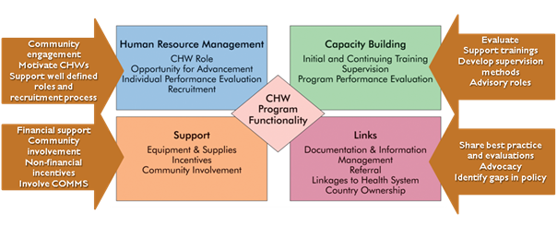
Figure 1. CHW AIM functionality Matrix and World Vision Support Mechanisms

It is important to note that models which are specifically aimed at CHWs such as Timed and Targeted Counselling (ttC) and Community Case Canagement (CCM) must have a complete CHW programming structure as a pre-requisite. A “complete” program refers not only to the selection/recruitment and training of CHWs, but also to the structures and systems that are necessary to support the CHWs in their work. It is not enough to train CHWs and “set them loose” without first ensuring that the essential components of a functional CHW program are in place. To the extent that CHW programmes already exist in the project area, the project must consider whether to work through these existing programmes, or through a different cadre of volunteers. Any existing CHW programme should be assessed as to its functionality, in order to feed into subsequent design decisions, which include plans to strengthen those areas found to be weak, as the necessary pre-requisite for launching the CHW programme and related model. As such, the bulk of activities within a project relating to the CHW Functionality Matrix and the assurance of the CHW standards below are clustered within community systems strengthening and health systems strengthening activities, elements which need to be emphasised clearly in project implementation plans and logframes.

CHW Principles of Practice
In addition to the CHW AIM functionality approach, we also stipulate that partnership approaches with the Ministry of Health and local health authorities should be taken in programme delivery, and that the ‘CHW Principle of Practice’ should be applied at every level, including at the ADP.

Vision Statement for CHW programmes:
Aim to work with existing health structures through strong, long-term partnerships in order to deliver consistently high standards of quality implementation, training and support, to enable community health workforces that are sustainable, functional and effective.

Work with national and regional health authorities and partners in order to:

- Advocate for the legitimization and recognition of the CHW workforce within the formal health system through appropriate country policies and task-shifting initiatives that support registration, accreditation and minimum standards for the role and performance of different cadres.

- Enable and support country leadership including national or regional coordination bodies empowered to provide oversight in CHW programme implementation across partner organizations and health authorities.

- Employ health systems strengthening approaches by avoiding the creation of parallel CHW services, methods and supply chains or competitive working practices.

- Establish standards and methods for performance-based incentives strategies which are ethical, non-competitive and sustainable, and under a unified country policy.

- Establish and agree on minimum standards for training of specific cadres of CHWs under an agreed unified system linked to performance-based accreditation.

- Establish unified mechanisms for reporting and management of community health worker data that promote consistent quality monitoring and accountability to existing health structures and communities.

- Invest in appropriate innovations judiciously through partnership approaches which will enable improvements to CHW work according to their capacity, and are available within the public domain.

Quality Standards for CHW Functionality
Essential Element & Recommended Practices | Minimum Standards for Implementation | Score | Reasons for deviation from MS
- CHW functionality assessment is carried out prior / during project planning phase  Recommended practices:  - Functionality assessment conducted at a national level assessing policy environment and guidelines during country readiness process for model expansion, (ttC / CCM).  - CHW-aim tool along with CHW demographic & educational profile information is captured during planning or baselines. The national office should co-ordinate assessment of current functioning of existing CHW programmes for 15 programme components preferably in collaboration with district health partners. | - CHW functionality assessment conducted as part of project baselining activities (or has been conducted at least once by the local or district health authority within the last 2 years).  - Health authorities engaged in design, implementation and evaluation of results.  - Results are shared with CHWs, COMM, local health authorities & MoH.
- CHW recruitment process is community-driven, transparent and engages all existing cadres without the creation of new ones.  Recommended practices:  - Community members and target beneficiaries are directly involved in recruitment through democratic process, and empowered to remove and re-elect CHW if deemed unfit.  - Selection criteria and core competencies are available and transparent to all those involved, and are appropriate for the country context (culture, language, literacy and gender). | - A minimum CHW-AIM score of 2 or above  - CHW is selected from the chosen community and currently resident there.  - Community is directly involved in the recruitment of the CHW, including women.
- CHW role is designed with clarity, including competencies with agreement of community, CHW, and health system.  Recommended practices:  - Process for discussion and update to role/expectations is in place for CHW and community.  - Expectations of CHW regarding time, role, protocol, incentives, supervision and training are clear and documented. Guidelines are aligned to National policies and available to health staff, community and CHW. | - A minimum CHW-AIM score of 2 or above
- Initial CHW training is sufficient to prepare them for their role with appropriate time, trainers and practical training.  Recommended practices:  - If required by the MOH, standardized basic training modules are to be completed prior to any subsequent training modules. Training is consistent with health facility guidelines and existing policies and local health staff conduct or are involved in training. All records of training should be maintained for future reference.  - Practical skills training and support included in curricula and given 25% of training time. | - All new training modules only introduced once basic competency based training required by MOH is completed.  - Field practical skills training during at least 1 day.  - Programme keeps a written record of trainings per individual (CHW record).
- On-going training is planned throughout the project cycle to ensure necessary revision, skills-building and considering estimated attrition rates.  Recommended practices:  - Ongoing training provided to update CHW on new skills, reinforce initial training, and ensure protocol compliance. Replacement rates can be as high as 40% per year and need estimating prior to project.  - Training is tracked and opportunities are offered in a consistent and fair manner to all CHWs.  - The health facilities are involved in all training events | - Refresher training plans for at least 4 days per year throughout the project cycle.  - Reselection and attrition rates are predicted at least 10%, and budgeted for 10% retraining of new volunteers per year.
- Equipment and supplies are available and sufficient to deliver services including medicines, supplies, and job aids.  Recommended practices:  - Medicines and materials are channelled through existing supply chains where possible, assure functionality avoiding parallel systems.  - Medicine supply is linked to supervisory mechanisms, and technically competent staff check and update stocks including expiration dates, quality and inventory to ensure no substantial stock-outs. | - Existing supply chains are utilised and strengthened during project.  - Stocks & job aids quality assessed at supervision at least twice per year (as part of supervision).
- CHW supervisors are competent, equipped and supported to conduct quality supervision on a regular basis.  Recommended practices:  - Supervisors are trained in supportive supervision methods and have basic super-vision tools (checklists) to aid them, and sound technical knowledge. Community, CHW and PHU have clear guidance on supervisor role  - Frequency: A suitable time frame is established for supervision, with face-to-face contact regularly planned. Include more supervision in year 1.  - Ratio: An appropriate supervision ratio of CHWs: supervisor is established- e.g. 30 CHW per supervisor.  - Data sharing: Supervision data are made available to community members and community health structures. | - Supervisors have completed a basic competence training on the programme model and are selected as those with a background in the technical area of implementation.  - At least 4 face to face contact with supervisor per year.
- Supervision activities are designed and implemented to identify and resolve individual performance quality.  Supervision, typical one of the weakest areas of programming, is essential for the learning progress of CHWs. Individual mentoring may have more impact on skills and quality than classroom training alone. Clinical models such as CCM and cPMTCT will require adequately trained clinical mentors.  Essential practices  - Case assessment: Home-visit / case assessment of recorded cases to ensure service quality, focussing on adverse events, referrals and follow up.  - Observation of service delivery: home visits done with CHW, providing skills coaching through observation.  - Record review and data collection / reporting: Data gathered is used for problem solving and coaching. Data quality is checked.  Highly recommended  - Qualitative data review - use of CHW diaries to review the information on the barriers to service access.  - Trouble shooting (technical advice) offered during supervision (if supervisor is technically competent).  - Problem solving (non technical) offered during supervision.  - Refresher training: Knowledge checking, revision exercises or additional training using the CHW manuals during supervision as required by CHW. | - Case assessments (at least 3 cases) for quality monitoring 4 times per year, especially important in CCM and treatment programmes.  - Observation of service delivery - At least twice per year, as soon as possible following training, and part of ‘approval’ of CHW training.  - Record review - at every supervision (4 times per year)  - Highly recommended practices ideally should be included at least twice per year (2 times in first 6 months of project)
- Individual Performance Evaluation occurs at least annually and is designed to fairly assess work and improve quality  - Progress evaluation individual performance (local evaluation) and evaluation of coverage /monitoring data using time-series data from the supervisions is in place and is widely known by supervisors, PHC staff and CHWs, incorporates community involvement including beneficiary feedback, and is linked to rewards (financial or other). | - At least once per year  , a minimum of 4 goal indicators of program coverage are tracked through time-series at the individual CHW level.  - Community inputs are incorporated  and performance is rewarded / recognised.
- Incentives - Standards and methods for performance-based incentives are ethical, non-competitive and sustainable, and under a unified country policy. ♦(see CHW Principles of practice for details)  Essential practices  - One Country One Policy - Where a national policy is not in existence, investigate the incentives paid by MOH and NGOs in the surrounding areas, convene meetings to achieve an agreement in which incentives will not vary widely or be competitive, at district or regional level if not national. MOH should sign off on the agreed rates.  - Community Participation and Accountability - Community involvement, transparency and accountability are very important in the determination of the incentives. To avoid conflict the incentives schemes need to be explained, agreed and documented in a transparent manner.  - Non-payment of services - CHWs should not receive financial incentives from the families for whom they provide services (sale of services method) as may result in service inequality to poorest households.  - Sustainability - Financial incentives paid for activities considered ‘business as usual’ including both short term and long term projects, an agreed stipend should be applied to all circumstances which can be recreated in an ADP budget or similar.  - Reasonable compensation - Incentives provided in line with expectations placed on CHW, based on the estimated number of work hours applied.  Highly recommended practices:  - Performance-based application - Linked to successful supervision or performance evaluation, subject to provision of expected services; not given for non-activity and reported misconduct by the community.  - Non-financial incentives and advancement - May include training, certification, advancement opportunities, formal recognition, uniforms, medicines, bicycles etc. These are awarded in accordance with project needs under agreement of local and national authorities. All non-financial incentives documented and transparent. | - Incentives are developed in collaboration with MOH and partners in line with local or national policies / practices.  - Community involved in incentives and provide feedback on performance which is taken into consideration.  - No payment for services is applied  - Incentive scheme is comparable and sustainable across all project types in the area.  - Incentives in line with expectations placed on CHW in time and opportunity cost.  - Incentives given are linked to performance based assessment and not given in cases where CHW is not active.  - Job tools (e.g. phones, bicycles) for exclusive use of CHW and are documented and transparent. They should not be given by beneficiaries as 'service in kind' payment.
- Communities are continuously engaged in the support of CHW’s work at all levels, and kept informed.  Recommended practices:  - Community including the beneficiaries should be involved in project from planning, feedback, review and incentives to the CHW.  - Community leader/s or existing health committees have ongoing dialogue with CHW regarding health issues in village using data gathered.  - Community provide feedback during supervision visits to resolve issues. | - Community wide meetings to discuss and sensitise on CHW initiatives should take place at least once per year.  - COMMS/CHCs should be involved in feedback review of CHW supervision at least twice per year (CHW debriefing sessions)
- Referral system for emergency evacuations of cases is in place and referrals documented  Recommended practices:  - CHW has a logistic plan for referral and current knowledge of emergency transport and funds if available. CHW records all emergency referrals recommended and then follows up in the home at least once to ensure referral compliance and care. CHWs to report / record the result of the referral and experience of client (client discharge guidance).  - Counter referral is encouraged to enable increased communication on specific cases to the CHW and to improve case management. | - A facilitated referral system is in place and referrals and evacuations are recorded.  - Post-referral follow up visits by CHWs are conducted for all emergency evacuations.  - Counter referral system is available to the health centre for severe /chronic cases.
- Opportunity for advancement, growth, promotion and retirement for CHW is considered  Recommended practices:  - Advancement (promotion) offered to CHWs who perform well and express interest in advancement if opportunity exists (formal accrediting / role change).  - Advancement rewards good performance or achievement, based on fair evaluation. | - A minimum CHW-AIM score of 2 or above
- Documentation, Information Management is in place which is consistent, transparent and used for service improvements  Recommended practices:  - CHWs document activities consistently using appropriate job aids. Supervisors monitor quality of documents and provide help when needed. CHWs work with supervisor or facility to use data in problem-solving at the community.  - Health staff involved in reviewing data and systems are aligned to HMIS. | - A minimum CHW-AIM score of 3  - Data submitted to health facility / authority on a quarterly basis.  - Data is made available to COMM twice per year
- Linkage to Health System  Recommended practices:  - CHWs are formally recognised by the health authority in a direct relationship and not solely to the project. Links between the community health structures managing CHWs are the district health authorities are built through regular communication, contact, meetings and training events. Two-way reporting and sharing or information and data are supported throughout the project cycle.  - Each CHW is assigned to a PHC technical staff member with a personal mentoring relationship and direct contact. | - A minimum CHW-AIM score of 2 or above  - CHW has a direct reporting relationship to the local health facility / authorities.  - CHW community management structures and district health teams should interact at least twice yearly.
- Program Performance Evaluation  Recommended practices:  General program evaluation of performance against targets, overall program objectives, and indicators that is carried out on a regular basis  - Yearly evaluation conducted of CHW activities (may be sample) assessing achievements in relation to program outcomes and targets.  - Includes evaluation of the quality and coverage of service delivery and community feedback. Health staff also provide feedback based on data received from CHW.  - Feedback given to CHWs on program indicators and targets and against standards. | - Program evaluation should aim to occur after 12 months in the first instance, then 18 monthly.  - Includes CHW functionality assessment and time-series programmatic data  - Report findings summary shared at local, regional and national levels with partners
- Country Ownership - National level MoH partners have a direct involvement, oversight and decision-making powers over programme methodology and implementation and review processes.  Recommended practices:  Ideally we should look to work through partners as much as possible, ensuring that all trainings and skills we support are building capacity of these state actors to continue the project in our absence.  - A National level committee coordinates CHW programming involving key stakeholders, MoH and partners.  - WV activities promote legitimisation of CHWs and task shifting within the national health service and are in alignment with existing MoH strategies.  - MoH partners are involved in training at national and regional levels and retain rights to review methods. MOH involved in all stages of including piloting, curricula choice and adaptation, incentives, data systems and evaluation.  - Adequate accompanying activities contributing to health systems strengthening are applied. | - A minimum CHW-AIM score of 2 or above

CHW AIM: A Toolkit for Improving Community Health Worker Programs and Services. Crigler L, Hill K, Furth R & Bjerregaard D, USAID Health Care Improvement Project/URC http://www.hciproject.org/node/1224

