May, 2017
The CHW Reference Guide Summary
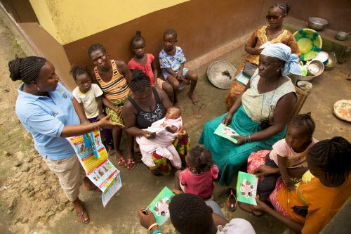

May 2017



Preface
The “CHW Reference Guide Summary,” presents a synopsis of the original 468-page document, Developing and Strengthening Community Health Worker Programs at Scale: A Reference Guide and Case Studies for Program Managers and Policymakers. The original CHW Reference Guide was spearheaded by Henry Perry in collaboration with 27 different subject experts who, collectively, have a formidable breadth and depth of experience and knowledge about CHW programming around the world. Originally published in May 2014 by USAID’s flagship Maternal and Child Health Integrated Program (MCHIP), it was created in response to the rapid increase in and expansion of CHW programs in low- and middle-income countries over the past decade. CHW Central has condensed the original guide into this 55-page summary document, which contains 16 chapter summaries by experts in the field, encapsulating the key-findings from the original CHW Reference Guide.

A global resource for and about Community Health Workers
chwcentral.org
CHW Central is a website dedicated to support CHWs and CHW programs in the United States and across the globe. Our goal is to strengthen CHW programs and activities through up-to-date resources, evidence-based practices, research and tools, platforms for asking questions, and news about upcoming events.
Provides a forum for continuous online discussions and exchanges with CHWs, public health professionals and program managers in the United States and across the globe.

Table of Contents

Chapter One: Introduction (Henry Perry, MD)…………………………….………………………….…………. | 3
Chapter Two: A Brief History of Large-Scale Community Health Worker Programs (Donna Bjerregaard MSW, CPHQ and Henry Perry, MD)………………….................................................. | 6
Chapter Three: National Planning for CHW Programs (Ranu S. Dhillon, MD)……………………… | 9
Chapter Four: Governing Large-Scale Community Health Worker Programs (Anya Guyer, MSc) ………………......................................................................................................................... | 13
Chapter Five: The Financing of Large-Scale Community Health Worker Programs (Ligia Paina, PhD) .............................................................................................................................. | 15
Chapter Six: Coordination & Partnerships for Community Health Worker Initiatives (Diana Frymus, MPH)…...................…...................…...................…...................…................................. | 20
Chapter Seven: Community Health Worker Roles and Tasks (Alfonso C. Rosales, MD, MPH)............................…...................…...................…...................…...................…................... | 23
Chapter Eight: Recruitment of Community Health Workers (Daniel Palazuelos, MD, MPH)…..…......................…...................…...................…...................…...................….................. | 25
Chapter Nine: Training Community Health Workers for Large-Scale Community-Based Health Care Programs (Paul Freeman, DrPH, MBBS, MHP, MPH )……………………………………… | 29
Chapter Ten: Supervision of Community Health Workers (Kate Tulenko, MD, MPH)…………. | 32
Chapter Eleven: What Motivates Community Health Workers? Designing Programs that Incentivize Community Health Worker Performance and Retention (Rebecca Furth, PhD)……………............................................................................................................................ | 35
Chapter Twelve: Community Health Worker Relationships with Other Parts of the Health System (Allison Annette Foster, MA)…………..………….…………………………………………………………. | 38
Chapter Thirteen: Community Participation in Large-Scale Community Health Worker Programs (Maryse Kok, PhD).................................................................................................... | 41
Chapter Fourteen: Scaling Up and Maintaining Effective Large-Scale Community Health Worker Programs (Emma Sacks, PhD)……………………………………………………………………………….. | 44
Chapter Fifteen: Measurement and Data Use for Services Provided by Community Health Workers (Jen McCutcheon, Msc , MPH, DrPH)…………………………………………………………………..  Chapter Sixteen: Case studies of large-scale community health worker programs: examples from Afghanistan, Bangladesh, Brazil, Ethiopia, India, Indonesia, Iran, Nepal, Pakistan, Rwanda, Zambia and Zimbabwe (Polly Walker, PhD)………………………………………….. | 48  52

Chapter One: Introduction
Summarized by Henry Perry, MD
In response to the rapid increase in and expansion of community health worker (CHW) programs in low-income countries over the past decade, my colleagues and I created, Developing and Strengthening Community Health Worker Programs at Scale: A Reference Guide and Case Studies for Program Managers and Policymakers, which we refer to as the CHW Reference Guide. The original document provides a thoughtful discussion about the structure and functions of large-scale CHW programs. Our goal is to assist planners, policy-makers, and program implementers in strengthening existing large-scale programs and in designing and scaling up new programs. This work was guided by a senior writing team composed of myself along with Lauren Crigler, Simon Lewin, Claire Glenton, Karen LeBan, and Steve Hodgins.
The original CHW Reference Guide, can be downloaded in its entirety of 468 pages or chapter by chapter. It contains chapters in four main sections:
- Setting the Stage (the history of CHW programs, planning, governance, financing, and national coordination and partnerships),
- Human Resources (roles and tasks, recruitment, training, supervision, and incentives),
- CHW Programs in Context (relationships with other parts of the health system, and relationships with the community), and
- Achieving Impact (scaling up and sustainability, and measurement and data use).
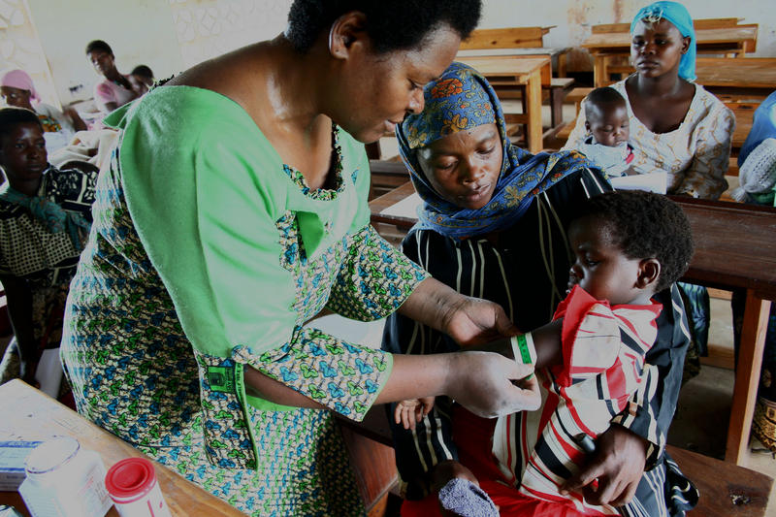
An extensive Appendix contains case studies, perspectives from key informants, and a list of other important resources. There are case studies of national CHW programs in 12 different countries: Afghanistan, Bangladesh, Brazil, Ethiopia, India, Indonesia, Iran, Nepal, Pakistan, Rwanda, Zambia, and Zimbabwe. The appendix has now been updated as a stand-alone book available online. These case studies are the most complete descriptions of these national CHW programs that are currently available. The appendix also contains a summary of interviews with experts who have experience working with large-scale CHW programs, which provides important insights into challenges that large-scale CHW programs face.
A student in a community health master’s degree program measures the mid-upper arm circumference of a child in Mangochi, Malawi
© Fletcher gong’a, Courtesy of Photoshare

The original CHW Reference Guide addresses issues and challenges that all large-scale CHW programs face, and it provides many examples of how specific programs have addressed these issues. It does not try to present simple (or single) solutions to these complex issues, but rather raises questions that need to be considered by policymakers and program implementers in their own particular context, along with possible options and resources for addressing these questions. The Guide does not address specific technical issues related to specific interventions (such as the types of interventions and services that CHWs can provide, the details of training and logistical support required for individual interventions, and so forth).
The increasing momentum for expanded and stronger CHW programs is a welcome development for so many of us who have long seen the potential for stronger community-based programs to improve the health of populations, and particularly to improve the health of mothers and children. There is growing evidence that impressive gains can be made in smaller populations with well-trained and well-supported CHWs implementing discrete interventions over a relative short period of time, including for health promotion and for the prevention and treatment of serious conditions that are leading causes of mortality. Furthermore, a substantial number of countries with strong, large-scale CHW programs have made remarkable progress in expanding the coverage of key maternal and child health interventions. These countries have shown impressive gains in reducing maternal and child mortality and in expanding the coverage of family planning services with concomitant reductions in fertility – for example, Bangladesh, Nepal, and Ethiopia.,
The resurgence in CHW programming has been slow in coming. The initial upswing of enthusiasm and experience with large-scale CHW programs in the late 1970s and early 1980s was associated with their endorsement at the International Conference on Primary Health Care and in the Declaration of Alma Ata.
The following chapters of this document summarize the key-findings from the original CHW Reference Guide. We are grateful to those who wrote these chapters and shared their perspective on the original full chapters.
Chapter One originally written by Henry Perry, MD

Chapter Two: A Brief History of Community Health Worker Programs
Summarized by Donna Bjerregaard, MSW, CPHQ and Henry Perry, MD
Developing and Strengthening Community Health Worker Programs at Scale: A Reference Guide and Case Studies for Program Managers and Policymakers helps us reflect on what we have learned about large-scale CHW programs and how to recruit, train, supervise, and incentivize CHWs. What can we learn about financing, roles and responsibilities, community involvement, and linkages with the health sector?
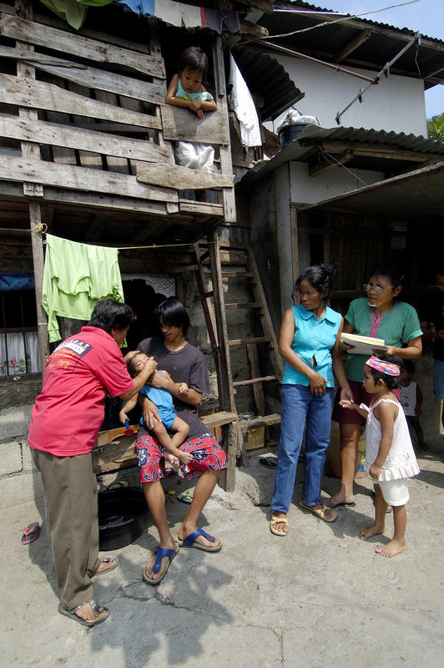
As we search for ways to develop large-scale CHW programs, it would be wise to look back at the roots of these programs. The first was in the 1920s in Ding Xian, China. Dr. John B. Grant (Rockefeller Foundation) and Jimmy Yen, a Chinese community development specialist, trained illiterate farmers to record births and deaths, vaccinate against diseases, give health talks, and explain how to keep wells clean. These trained farmers become known as Barefoot Doctors; by 1972 there were one million Barefoot Doctors serving 800 million people in rural China.
Faced with the need to address the health of rural populations in the 1960s, the Barefoot Doctor model was adapted in other countries, including Honduras, India, Indonesia, Tanzania, and Venezuela. It led to a new approach to health services, based on the principles of social justice, equity, community participation, prevention, collaboration, and decentralization. This movement also led to the health team concept that included community-based workers to strengthen health and welfare in communities.
In 1978, influenced by the work of the Christian Medical Commission, the World Health Organization and UNICEF sponsored an international conference on primary health care which led to the Alma-Ata Declaration of Health for All. It also defined CHWs as important providers of primary health care. In the 1970s and 1980s, national CHW programs were developed in Indonesia, India, Nepal, Zimbabwe, Tanzania, Malawi, Mozambique, Nicaragua and Honduras as well as other Latin American countries. In the same period, smaller CHW programs were started by non-governmental organizations in low-income countries. But the national programs were beset by lack of political will and as inadequate training, supervision, remuneration, incentives, support for logistics, acceptance by formal health care providers, and financial support for program operations. Many governments reduced or discontinued their large CHW programs in the 80s and early 90s in favor of vertical programs that had strong donor and technical support.
Carmen Morano, a village health worker in Paltao, Philippines, applies vitamin drops to children in a poor community. Morano and other local health workers have benefited from workshoips sponsored by KFFI, a Philippine NGO.
©2005 Paul Jeffrey, Courtesy of Photoshare
Evolution
The effective functioning of large-scale CHW programs offers one of the most important opportunities for improving the health of impoverished populations in low-income countries. Research findings on the effect of community-based programs in improving child health have led to a resurgence of interest in CHW programs around the world.
In the 1980s and 1990s, there was a loss of momentum of the primary health care movement envisioned at Alma-Ata. A global recession and a push to reduce public sector financing led to loss of support for health initiatives in general. Successful examples of CHW programs emerged in the mid-1980s. In 1987, Brazil’s national health care program started and gradually achieved universal coverage of health services. In the country’s 8th National Health Conference, the principle that health is “a citizen’s right and the state’s duty” was established. Brazil has one of the largest CHW networks in the world: 222,280 CHWs providing home visits and services to 110 million people.
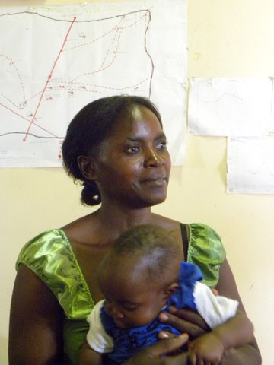
In the 1990s, more examples of large-scale programs appeared. In 1997 Bangladesh had 30,000 female CHWs providing home-based family planning services. Bangladesh’s family planning program is now regarded as one of the most successful programs in a developing country not undergoing rapid socioeconomic development. Malawi’s CHW Program began in the 1950s providing immunizations by salaried Health Surveillance Assistants (HSA). In 2008, Global Fund assistance enabled the government to double its HSA workforce to 10,000.
The evidence regarding the effectiveness of CHW interventions in maternal and child health has gradually emerged, leading to stronger investments in CHW programs to enable countries to accelerate progress in achieving the Millennium Development Goals (MDGs), particularly MDGs 4 and 5 for reducing child and maternal mortality. Interest has also grown in decentralization as a way to reach the poorer segments of the population with services for every household. In 2004, Ethiopia started its Health Extension Worker program, which has enabled it to reach the MDG for child health by training 38,000 CHWs in five years and reaching every household with basic services.
Photo credit: Donna Bjerregaard
The lessons learned from the past help us to see what is important today as we move toward expanding and strengthening large-scale CHW programs. Ensuring financial sustainability and quality improvements through monitoring and periodic evaluations will be essential if programs are to achieve long-term viability and maximum impact on health.
Chapter Two originally written by Henry Perry, MD

Chapter Three: National Planning for Community Health Worker Programs
Summarized by Ranu S. Dhillon, MD
The overview provided in Chapter Three: National Planning for Community Health Worker Programs (Gergen, Perry and Crigler) closely mirrors my experience helping to design the Village Health Workers program in Nigeria, develop the plan for a national CHW program for Guinea, and strengthen the ASHA (Accredited Social Health Activist) program in different states of India. Based on these experiences, there are several pragmatic insights that build on points articulated in the chapter:
Positioning the process
The impetus for planning a national CHW program can come from many directions and greatly influences who leads the process and how it plays out. Regardless of how the idea initially takes root, it is important for the process to be embedded as early on as possible within an agency that has the clout and positioning to carry it forward. Without this combination of authority and structure, it is very difficult for CHW programs to gain the traction they need and enter the mainstream policymaking discussions, particularly since they require additional budgetary allocations. Understanding the political economy unique to each country and situating the program with the right support and vehicle is crucial for its success.
Identifying a core group and key partner(s)
The process of conceptualizing, planning, and then rolling out a national CHW program can be daunting and requires collaboration with multiple partners in the health sector. In both Nigeria and Guinea, we formed a core group of top Ministry officials and global experts who could do the preliminary legwork for the program and structure the process by which stakeholders could contribute to its development. This approach ensured there was enough substance to guide initial discussions as well as a clear team to coordinate the process once stakeholders were engaged. It also ensured that early conversations did not become too diffuse and could be directed towards concrete decisions and action steps. For driving the overall process, though, it may be beneficial to identify and engage one or two key partners with particularly strong interest in seeing the program established who could support the government through the critical initial steps when a program can get stuck and die before it even gets started or set out on a misguided path that becomes difficult to redirect further down the line.
Thinking about decentralization
A crucial decision for national CHW programs is how different functions—setting policy, operational planning, financing, managing implementation, monitoring and evaluating—are organized across different levels of government. Deliberate consideration is needed in how overall planning and, ultimately, execution of these elements takes place at each level. This must be country specific based on political dynamics, existing administrative structures, and the distribution of capacity. Beyond planning, similar decisions about decentralizing discretion need to be thought through for other functions of the program, such as financing and monitoring and evaluation. It is important that these choices are carefully evaluated during the planning phase.
Calibrating the operational model
There are many examples of CHW programs, but it is essential that a national program be tailored to each country and locality. Rather than putting forward a generic model, each country’s CHW program should be matched to the exact needs and gaps of its health system and then adjusted to the capacity present at the local level. For example, in India there is tremendous variation across different states. Though there is a general policy for how ASHAs—the CHW cadre in India—should operate, the operational model must be adjusted to each state. In the state of Assam, for example, maternal and child health needs predominate and many of the women who are eligible to become ASHAs will not be literate. This differs from Punjab where cardiovascular disease and heroin are major health issues and many villages have high school and even college-educated women who could potentially become ASHAs. With this in mind, the model for what an ASHA does and how she operates within the broader health system should look very different in Assam than in Punjab. Rather than simply importing best practices from abroad or using a blanket one-size-fits-all approach, national programs should combine a nuanced understanding of the needs and the capacity of people who can be trained as CHWs to
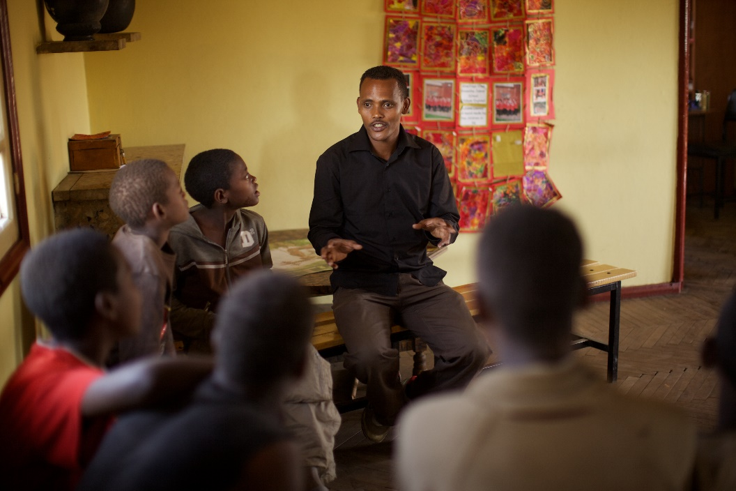
develop their model.
Photo credit: Hammond, 2011

Specifying the details of training and management
The chapter underscores the need to plan how training and management will be carried out, and how a lack of attention on these features has been a pitfall for many programs. A strategy for these essential functions should be clearly spelled out during the planning process. As the chapter describes, these tasks are often levied onto primary health level professionals—many of whom have no skills or training as managers—to take on in addition to their regular work.
Planning the CHW program has to be as much about setting up essential support mechanisms as actually deploying the CHWs. Without dedicated resources and potentially even institutions to execute training, CHW programs, especially at national scale, are doomed to underperform. In the same way, managing CHWs in the field may be one of the most important ingredients for success and should be carefully planned out. Training for managers and tools to guide them in their supervisory role, as well as clear reporting protocols, need to be developed. If the importance and scope of these tasks are not taken into account during the formative planning stage, the program is bound to run into problems once planning shifts to implementation.
Iterating design and performance
In health, the mindset is usually to plan out the “ideal” approach based on available evidence and norms and then implement it with the assumption that performance will follow. This way of doing things needs to be reoriented to the way engineers approach problems—using best practices to frame an initial approach and then use real experience and data to replicate it—and be built into the planning and execution of national CHW programs. The chapter describes the idea of re-planning these programs every five to ten years. In practice, though, there needs to be mechanisms for continual improvement on a tighter cycle, even quarterly, especially at the outset when a program is first introduced and likely to encounter several ‘bugs’ (i.e., training period needs to be made longer, managers need more support). CHW programs need to incorporate real-time information systems such as those that can be facilitated by mHealth tools to enable dynamic management that constantly reacts to feedback. In this regard, planning a national CHW program requires in-depth engagement with the country’s information systems so that CHWs’ actions on the ground and data on health systems can be built out synergistically.
Conclusion
Altogether, the authors provide a very clear and methodical process for building national CHW programs that resonates with my own experience. Paying close attention to the details—of political context, of what should be done at each level of the system, of what specific needs can CHWs really meet, of how training and management will happen, of how the program will refine its assumptions—is critical in the planning stages. If these details are not thought through carefully, it can be difficult to get the program the legs it needs to get started or lead to challenges that become more difficult to resolve once the program is already up and running.
Chapter Three originally written by Jessica Gergen, MSPH, Lauren Crigler, MA, and Henry Perry, MD

Chapter Four: Governing Large-Scale Community Health Worker Programs
Summarized by Anya Guyer, MSc
“Who’s in charge here?” can be a hard question for CHW programs to answer, particularly those that operate on the large scale. Who are the people and institutions that make decisions about running a program? How do they arrive at their decisions? And how are these decisions implemented and enforced? Things rapidly become complicated for CHW programs as they may or may not be part of the formal health system. CHWs may answer to multiple authorities including local health workers, vertical program managers and community leaders, as well as their clients and patients; and, what works very well in one area may not be appropriate in another place.
Figuring out “who’s in charge” is what governance is all about. In the CHW Reference Guide’s Chapter Four, authors Simon Lewin and Uta Lehmann use this definition for governance: “the processes and structures through which individuals and groups exercise rights, resolve differences and express interests.” They emphasize that governance encompasses actors, structures, and the interactions among these actors and structures.
Any discussion of governance has to define what, in particular, is good governance. Building on the previous definition, good governance can be understood as processes for decision-making and implementation that are fair, transparent, and consensus-oriented, and which result in programs that promote the public good and human rights. Ideally, good governance generates positive outcomes for the beneficiaries of any program.
As you may already have gathered from even just the first few sentences of this summary, thinking about the governance of CHW programs generates many follow-on questions. Governance is also a continuously ongoing process; for CHW programs the process is rarely clearly defined or linear.
To address all of this, Chapter Four articulates four key questions about governance of CHW programs:
- How, and where within political structures, are policies made for CHW programs?
- Who, and at what levels of government, implements decisions regarding CHW programs?
- What laws and regulations are needed to support the program?
- How should the program be adapted across different settings of groups in the country or region?
In the chapter, each of these questions, along with detailed sub-questions (see Table 2, pp. 14-15 of the CHW Reference Guide), is addressed in depth, with examples and case studies from across the globe provided to make the discussion more concrete. These include short summaries from Brazil, India, and Zimbabwe. The Zimbabwe summary, for example, discusses what happened when the government-created structures that were supposed to involve communities proved not to mesh well with existing community structures. Informative tables (see Tables 3 and 4, pp. 16-27) appended to the chapter provide even more details about the governance of the large-scale CHW programs in Brazil, Ethiopia, India, Pakistan, and South Africa.
The chapter emphasizes two additional points on governance:
- First, developing an understanding of the contexts—from local and national—in which a CHW program works is fundamentally important. Every community, health system, and government operates differently. A committee structure that works well in one part of India may not be able to have any influence in a different region that has different traditional authority structures. Policies handed down from a central government body may not be relevant to the challenges facing a minority community. These variations need to be accounted for in CHW programs if they hope to remain acceptable and relevant to the community they hope to serve.
- Secondly, for good governance to be established and sustained, resources—notably time and money—must be made available for governance processes. Programs need to allocate resources to enable the right people to come together to engage in governance processes, including policy debates, planning sessions, communication and engagement of the beneficiary communities and CHWs, and monitoring and evaluation of programmatic outcomes. Without adequate resources for these activities, the practice of governance will be severely hampered; without good governance, a program will eventually falter.
At the end of the chapter, Lewin and Lehmann comment that, “Policymakers and other stakeholders in each setting need to consider what systems are currently in place and what might work in their context and develop a locally tailored governance approach.” This chapter provides policymakers and other stakeholders with a critical tool: a list of clearly articulated questions that need to be answered in order to answer the big question of “who’s in charge?” Governing a CHW program is complicated, but the suggestions and examples provided in Chapter Four can help decision-makers better understand the range of options they must consider.

Chapter Four originally written by Simon Lewin, MBChB PhD, and Uta Lehmann, PhD

Chapter Five: The Financing of Large-Scale Community Health Worker Programs
Summarized by Ligia Paina, PhD
The relevance of CHW programs withstands the test of time, as current discussions are shifting from the Millennium Development Goals to the Sustainable Development Goals and to Universal Health Coverage. The “One Million Community Health Workers Campaign,” among others, is working to support low- and middle-income country governments to increase the number and quality of lay health workers. However, despite the strong enthusiasm for introducing and scaling-up CHW programs and the associated opportunities to increase community access to essential health services, challenges persist in the move from policy to implementation, from pilots to large-scale programs.
The misconception that CHW programs are cheap to implement and sustain has been a major barrier to scale-up of recent initiatives and a key factor in the failures of these programs in the past, particularly in the 1980s. In Chapter Five of the CHW Reference Guide, authors Henry Perry, Francisco Sierra-Esteban, and Peter Berman help us to move beyond these misconceptions by systematically thinking through what financing CHW programs means in practice and how to understand and analyze costs through planning and implementation.
The authors argue that the failure to consider the “real costs of CHW programs” has led to low effectiveness of CHW programs in the decades following the Alma-Ata call to action. They caution that history might repeat itself if, in the future, we fail to acknowledge the full resources required for the implementation and scale-up of CHW programs, as well as where these resources might come from.
Chapter Five guides us through the following key questions:
- What are the elements of CHW programs that need to be included in cost calculations?
- What are the full costs of CHW programs?
- What are the different options for the financing of CHW programs and the strengths and limitations of each option? What are some examples of how CHW programs have been financed?
- What guidance can be given to assure that financing becomes a sustainable positive element in CHW program development?

Table 1
Type of Cost | Investment Costs | Recurring Costs
Direct | Initial Planning, management, and administration | Ongoing planning, management, and administration
Direct | Establishing governance and stewardship (including certification, accreditation, and quality control) | Ongoing costs of governance and stewardship (including certification, accreditation, and quality control)
Direct | Developing training institutions, and initial training of CHWs and supervisors | Costs of continuing education of CHWs and supervisors
Direct | Initial recruitment and training of CHWs and supervisors | Costs of recruitment and training of new CHWs and supervisors
Direct | Initial orientation of health staff
Direct | Initial community engagement, engagement with community leaders, and community mobilization (including publicity) | Ongoing costs of maintaining community engagement, engagement with community leaders, and community mobilization
Direct | Initial costs of determining renumeration, setting up the payment system, producing the first set of uniforms, identification badges, etc. | Salaries and benefits for CHWs and their supervisors, accessories for identification of CHWs (uniforms, badges, etc.), other incentives (e.g., costs of community appreciation days)
Direct | Initial purchase, materials, suplies and medicines, drug kits | Annual purchase of materials, supplies, medicines, and drug kits including contracting and procurement costs as well as distribution costs
Direct | Initial purchase of equipment, furniture, and vehicles | Maintenance or rent of vehicles, furniture, and equipment; fuel
Direct | Costs of buying or building new operational facilities for CHW program mangement and for training CHWs (CHWs are not based in facilities) | Utility bills, maintenance, and repairs
Direct | Planning of monitoring and evaluation | Ongoing monitoring and evaluation
Indirect |  | Costs incurred by CHWs themselves (out-of-pocket expenses they have to make to carry out their work, opportunity costs)  Costs to the health system of additional health care generated by CHW referrals  Costs to the patients and their families for services provided by CHWs  Costs of high CHW turnover (disruption of servies, low staff morale, poor quality, recruitment of replacements)

A helpful typology, aimed at those engaged in planning the development of a CHW program, is provided to facilitate a thorough understanding of investment and recurrent direct and indirect costs (see Table 1). Special emphasis is placed on indirect costs, which can be incurred even when CHWs are volunteers, i.e., the costs incurred by CHWs themselves (e.g., opportunity costs what a CHW could have earned if she had not been working as a CHW) and the costs to the health system, both in terms of the additional demand generated for health care or the cost of turnover.
Chapter Five also emphasizes that the evidence on how much CHW programs cost is limited and that the cost estimates depend greatly on the context and the particular costing approach used. There are four elements that the authors suggest should be included in a thorough cost analysis:
- The monthly salary/compensation/incentive for each CHW
- The annual cost per CHW – the sum of direct and indirect program costs) necessary to implement the CHW program, divided by the total number of CHWs available.
- The annual cost per program beneficiary or per capita - the sum of direct and indirect program costs necessary to implement the CHW program, divided by the total population.
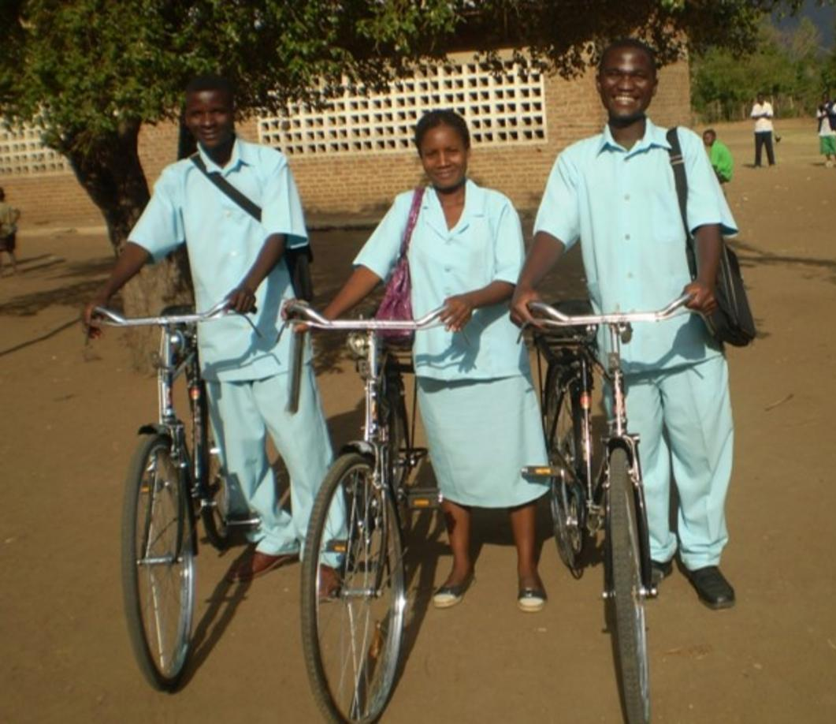
- The source of funding (see Table 2, pages 8 to 9 of CHW Reference Guide, and Annex A, for examples)

As previously stated, context is particularly important. For example, female community health volunteers in Nepal receive free medical care but do not receive a monthly salary, but CHWs in Pakistan earn up to $50 per month and CHWs in Brazil earn between $100 and $200 per month. Full program costs can be framed in terms of the cost per CHW and must include all investment and recurrent costs (e.g., training, salary, supervision, etc.). Cost estimates can become more complicated depending on the type of services provided by the CHW and who is conducting the supervision. These are sometimes compared with the costs that might be incurred to place a medical professional in the same areas – the latter being significantly more expensive. The authors also point out that the scale of the program also matters when costing. As the program scales up, its unit costs might increase as it expands into hard to reach areas, where the marginal cost per person is higher than otherwise.
Health workers with their bicycles in Malawi.
© 2016 VillageReach, Courtesy of Photoshare
In terms of sources of funding, it is most important to consider:
- Who bears the burden of financing
- Whether the selected financing mechanisms have built-in incentives for efficiency and quality
- The degree of sustainability and potential risks
The authors identify national governments, communities, and development partners as the main sources of financing for the CHW programs. They note that although CHWs may be unpaid, CHWs are themselves a major funding source for the program, as CHWs are donating their time. Usually, CHW programs, such as the ones described from Bangladesh and Brazil, are supported by several sources of funding.
Finally, Chapter Five highlights the following principles as guidance for ensuring sustainable financing for CHW programs:
- Careful planning that takes into account full program costs
- The establishment of a strong base of political support for long-term financing, especially if the government is a major funding source
- Developing strong linkages to local, private sources of revenue, anticipating that these can grow faster than central government funding
- Remunerating and incentivizing the CHWs (e.g., with career opportunities) will decrease the odds of attrition; the lower the attrition, the lower the program costs and the higher the potential for quality services
The case studies provided in Boxes 2 and 3 (CHW Reference Guide Chapter Five pages 12 to 14), as well as the ones in Appendix A, provide a wealth of information on the current state of CHW programs and what is known about their costs.
To review, the authors of this chapter make a strong case for:
- Recognizing that CHW programs and their cost have to be adapted to the local environment
- Integrating CHW programs into the broader health system – in terms of financing commitments as much as in terms of employment, supervision, and support
- Donors and national government investing sufficient resources towards proper costing and planning for sustainable financing
Sustainable and predictable financing for CHW programs can help these programs reach their full potential and scale. Strong CHW programs can contribute to systems resilience and scaling up response to crises, such as the Ebola epidemic, and, more broadly, to the current efforts towards Universal Health Coverage.
Chapter Five the written by Henry Perry, MD, Francisco Sierra Esteban, MSc, and Peter Berman, MSc, PhD

Chapter Six: Coordination & Partnerships for Community Health Worker Initiatives
Summarized by Diana Frymus, MPH
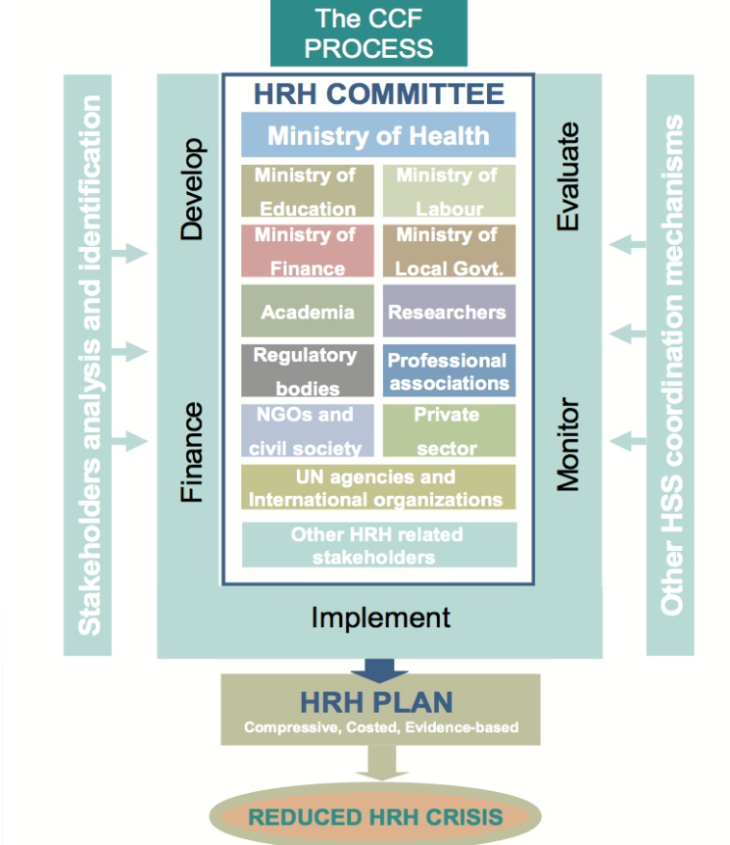
Fragmented country-level programming and utilization of CHWs contribute to the ambiguity of CHW program ownership and accountability. In Chapter Six of the CHW Reference Guide, Muhammad Mahmood Afzal and Henry Perry recommend several existing coordination mechanisms and approaches that could guide harmonization of CHW support, such as the Country Coordination and Facilitation (CCF) approach for the human resources for health (HRH) agenda (see framework at right). Chapter Six also presents an overview of the CHW Partner Commitment’s guiding principles and proposed framework to enable stronger alignment and integration of CHWs into national health systems and workforces. The chapter proposes that taken together, these approaches can provide a roadmap for coordination and partnership to strengthen the accountability of CHWs, their effectiveness, and sustainability as a cadre of the broader health workforce.
Reflection
This discussion is timely; CHWs continue to garner increasing global attention that brings greater urgency to the need for stronger coordination and partnership. The authors discuss CHWs within the complex human resources for health (HRH) stakeholder environment spanning multiple ministries, academia, professional councils, regulatory bodies, and more. CHWs represent only one type of cadre within a country’s health workforce, but the stakeholder landscape for CHWs is more complex. At the country level, entities that hold ownership and accountability for CHWs are often unclear, and the role of civil society and community constituents in placing CHWs within the communities they serve is also critical.
The global HRH agenda provides a central platform in which all players and stakeholders can come together to engage on CHW issues. The recent (2015) Addis Ababa Call to Action further demonstrates this opportunity. CHW performance is dependent upon the availability and accessibility of their facility-based health worker counterparts. These health workers, commonly designated as CHW supervisors, are also essential for providing care and services to clients who are referred by CHWs in the community. Achievement of universal health coverage (UHC) and global health goals requires greater focus on strengthening the entirety of the workforce and how it operates.
The 2013 CHW Partner Commitment drew attention to the need for stronger integration of CHWs into broader HRH efforts, although the extent of country-level implementation remains unclear. Ample opportunity remains across the current global health landscape for further utilization of the Commitment’s principles and framework for greater harmonization of efforts.
Conclusions
Chapter Six suggests that existing platforms and thought leadership for addressing the challenges of fragmented CHW programming be utilized as a foundation for building stronger coordination and partnership for CHW initiatives. Within the current landscape for CHWs and HRH, the commentator suggests:
- Stronger coordination and partnership at both global and country levels. Globally, CHW partners across various initiatives and agendas need to coalesce around CHWs for better understanding of respective priorities and commonalities. Most likely challenges impeding CHW effectiveness and sustainability across agendas are very similar, if not the same. At the country level, alignment of support for CHWs is needed for enabling greater and more sustainable impact at scale. The key is to increase overall accountability and ownership for CHWs, avoid duplicity of efforts, and create greater efficiencies where there are limited resources.
- Greater utilization of existing coordination mechanisms to avoid the risk of further fragmentation of CHW efforts. Country-level landscape analyses should be conducted to identify existing coordination mechanisms to facilitate communication, decision-making, and sharing of data. Integrating CHWs within national health workforces, increasing engagement, and continuing to build capacity of existing platforms for human resources for health is critical.
- Greater engagement with the global HRH agenda. As the World Health Organization (WHO) continues to develop the new global strategy on HRH, there will be multiple opportunities to provide input and feedback. CHW players should increase their interaction with the global dialogue. This will be essential for greater recognition and focus on CHWs as countries and partners apply the new strategy to address the HRH challenges to achieving health goals and UHC.
Chapter Six originally written by Muhammad Mahmood Afzal, MD, and Henry Perry, MD

Chapter Seven: Community Health Worker Roles and Tasks
Summarized by Alfonso C. Rosales, MD, MPH
Chapter Seven of the CHW Reference Guide describes CHW roles and tasks, and focuses on key points in planning, designing, or expanding new CHW roles. To be effective and efficient, CHW programs need to be tailored to context-specific situations. Likewise, the roles and functions of CHWs need to be aligned with supporters and users of services, most importantly at the local level. Factors related to implementation feasibility, need, and safety should be incorporated within an operational framework. Moreover, the planning process requires that specific tasks be clearly defined in order to assure appropriateness to need, user and provider acceptance, and general support from the health system.
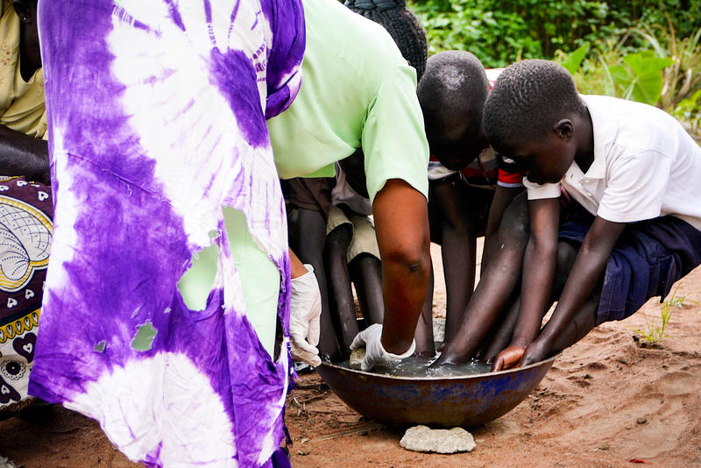
The World Health Organization recommends that planners take into consideration current research and evidence-based guidelines to ensure the effectiveness and safety of tasks performed by CHWs. Yet the lack of practical guidelines currently available for most local and international health program planners impedes progress. The authors, Glenton and Javadi, provide a thorough review of the most common roles CHWs have according to the most updated published and grey literature available. This review includes relevant and practical examples of national CHW programs currently being implemented in the developing world. The authors suggest that health planners address seven priority questions, laid out logically and sequentially, to build their design. Each priority question is presented with sub questions to prompt further considerations.
Gladys, a community health worker, in Western Kenya, provides jiggers treatment for three boys in a small tub of clean water.
©2013 Molly Snell, Courtesy of Photoshare

- How effective and safe will it be to use CHWs to perform a specific task?
- How can policymakers and program planners best assess the effectiveness, acceptability, and feasibility of CHW tasks for future interventions.
- Are CHW roles and tasks likely to be regarded as acceptable and appropriate by CHWs and their target population?
- Is there agreement among CHWs, beneficiaries, leaders, family members, and the wider community that roles are acceptable and their context and nature appropriate?
- How many tasks and activities should each CHW take on?
- Should CHWs be generalists or specialists? Are CHWs and community members involved in these decisions?
- When and where will each task be performed and what is the workload required?
- Are planners looking at the need for transportation, safety, quality, and incentives?
- What kind of skills and training will the CHW require when performing specific tasks?
- Is the task complex or tailored to recipients’ needs, circumstances, and local context? Is a complex diagnosis needed and are CHWs able to deal with complications?
- What type of health system support will the CHW require when performing the task?
- Are supervision, means of communication, access to supplies, and a referral chain in place?
- How much will it cost to use CHWs to perform the task?
- Are the costs of training, supervision, transport, wages and other incentives, equipment and supplies, and effective referral systems factored in?

Each question is succinctly answered using the latest literature and globally available guidelines. Further practical and real-life examples from Afghanistan, Bangladesh, Brazil, Ethiopia, India, Indonesia, Iran, Nepal, Pakistan, Rwanda, Zambia, and Zimbabwe national CHW programs complement this information to bring an air of reality to the reader.
In conclusion, as a health planner practitioner, Chapter Seven was extremely useful in guiding my thought process and helping me to include and understand the most critical components in designing CHW programs. Additionally, it provided me with the latest available evidence and resources to review in case a more extensive literature review is needed. An easy and enjoyable reading experience!
Chapter Seven originally written by Claire Glenton, PhD, and Dena Javadi, MS

Chapter Eight: Recruitment of Community Health Workers
Summarized by Daniel Palazuelos, MD, MPH
This chapter focuses on what might seem like a simple step in CHW program construction: the recruitment and selection of CHWs. This chapter shows us, however, that getting the right people to do the right job well requires thoughtful planning and knowledge of common pitfalls. If implemented thoughtfully, the authors, Jaskiewicz and Deussom, explain how the process by which CHWs are employed can be the crux that decides whether: 1) that program will reach its highest aspirations, 2) the community will be given substantive opportunities to engage in the process, and 3) the program will later be hobbled by unacceptable, and expensive, levels of attrition.
The (so-called) standard procedure of recruiting, selecting and hiring (and where it can go wrong)
Ideally, the CHW recruitment process will cover the following steps: “establishing criteria, communicating CHW opportunities to identify candidates, interviewing and selecting CHWs from candidates, and hiring selected CHWs.” Commonly, this can look like the following: the CHW program advertises a position in local media, communities nominate candidates via civil society organizations or public gatherings, and finally the program makes hiring decisions based on internal criteria like literacy and attitude. Variations exist, but increasingly in most programs, the community is only consulted whereas the health system holds the final power to choose “who makes the cut.” As one community organization representative once said, “when it comes to ‘community participation in health,’ we participate, but they decide…” What this statement, said with discontent, tells us is that deciding is power, and if that power is not shared in some substantive way, communities can feel disengaged.
The holy grail of selection and community engagement – balancing education and participation
The Alma Ata Declaration was not only an announcement but also a challenge: “Primary health care (PHC) requires and promotes maximum community… self-reliance and participation in the planning, organization, operation, and control of PHC.” Control is the operative word here, but it goes on: “and to this end [PHC] develops through appropriate education the ability of communities to participate.” What is being described is the balance between empowerment in the form of guidance and pragmatic solidarity (which means being cognizant of how solidarity should also be shown in material ways), and partnership in the form of shared decision-making and mutual respect.
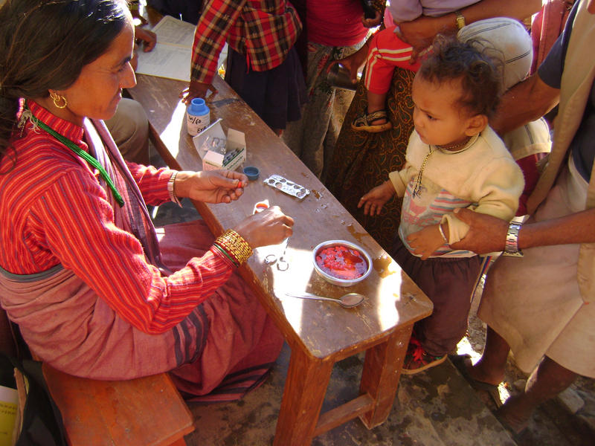
CHW selection is a key point where this balance between community control and learning to participate can set out on the right, or wrong, foot. Power sharing is manifested by the attitude and actions of program architects and staff when interacting with target communities and local leaders. Practically, this means assuring that the program is well aligned with community priorities and that clear mechanisms exist to not only make decisions collectively through democratic processes, but also share resources fairly. This is not straightforward, but this chapter gives many examples of where this has worked. What follows are key lessons learned, boiled down for quick consideration.
What to do
Program performance can only be as good as program design. Program architects, namely those stakeholders who can influence how funds will be used, should begin by considering the roles, responsibilities, and tasks that CHWs will undertake. Concretely, the tasks a CHW is asked to do are what they and their beneficiaries will see every day. A common mistake is to decide on a mission, i.e. to reduce maternal mortality, and then immediately begin recruitment without a clear map of how CHWs will contribute. In the case of maternal mortality, for example: will CHWs educate mothers, accompany them to birthing centers by walking many hours, and/or provide misoprostol and gentamycin in emergencies during home births? These tasks require different skills, different levels of support, and may be best performed by different candidates: perhaps older women will be most credible to educate mothers to change behavior, while only the healthiest could walk for hours each day to accompany patients to health centers.
A young boy, supported by his grandfather, waits for the local female Community Health Volunteer as she prepares to administer his dose of Vitamin A in the schoolyard of his village outside of Pokhara, Nepal. This dosing is a part of the Government of Nepal's biannual national Vitamin A distribution, implemented by a cadre of 49,000 local female volunteers, many of them mothers themselves.
© 2009 Laura R. Seckel, Courtesy of Photoshare

Literacy is often important, but not everyone who knows how to read also knows how to counsel and persuade. For example, our CHW program in PIH-Mexico involves behavior change in the most marginalized communities with chronic diseases; for this reason, we prioritize a local reputation for compassion over reading and writing skills (although all applicants must have some basic literacy). Imperfect literacy may lead to poor spelling in reports, but the real goal is not grammar – it is to reach and support people as they begin to live their life with a new diagnosis.
With a job description of high-value tasks in mind, program architects can then build out an effective programmatic milieu: what tools, what levels of supportive supervision, what financial incentives, will be most useful? Recruiters can present this full package of support to potential candidates to communicate what they are signing up for. The more concrete the terms of engagement, the more assured one can be that a CHW is signing up with clear expectations of what lies ahead.
Now with a job description and support system mapped out, program architects can confidently define the target community, and consider whom in that community is available to do the job best. Program architects need to be close to, and in continuous dialogue with, the communities being served. How to maintain this communication is not straightforward, but it usually entails being present often, walking on-site, and having regular conversations with local leaders and with intended program beneficiaries. To say it simply, the best CHW program decision makers will usually make those decisions with dust on their shoes. This can be logistically challenging for large programs, or for those that have to recruit from outside of target communities because of a shortage of available candidates, but this type of close feedback should be seen as a non-negotiable and sought out.
What NOT to do: common pitfalls and challenges
There are many ways in which CHW selection can run awry. Here are top considerations both from this chapter and my own experiences:
- Recognize and mitigate nepotism early: if the nomination or selection process is left to powerful community members, they may favor their friends and family over talent. One way to avoid this is to offer multiple, simple methods for candidate nomination, and then follow a transparent selection process that allows best candidates to stand out to both program directors and community leaders, such as observing candidate performance in a mock patient encounter. Here is a key example where participation and education to participate are critical to get right; setting a standard that nepotism is not acceptable is okay, as long as the rationale behind this is well explained and such limitations are not placed at every decision point. The ultimate goal is to be as adaptable as possible.
- Consider the candidate as a full package: many programs demand a lot of CHWs and seek to hire only those with the highest literacy, considering this a proxy for ability. A focus on any single, measurable trait can lead to tradeoffs. In the case of high literacy, for example, men and young people may have greater access to schooling, while older experienced female caregivers with great social capital and compassion may be largely excluded from selection. Higher literacy candidates will also often have other options and may be harder to retain long-term.
- Simple definitions of “community” may lead to complex consequences: program architects’ decisions will only be as good as their understanding of the community. If this understanding is superficial, it may lead to a program that crumbles under the weight of rocky performance. A classic example is considering “a community” to be people living in a certain geographic area. Yet, as we know from our own neighborhoods or workplaces, people in a single area may divide among themselves into many sub-communities. Sometimes these groups hold deep-seated resentments and mistrust for one another. Hiring a CHW from one sub-group to represent another will often simply not work. Key moments of community engagement, such as when CHWs are recruited, can bridge or inadvertently reinforce these schisms, especially when that engagement confers material benefits like employment and social capital. The best way to avoid this, again, is to walk and talk with the beneficiaries, asking the right questions, to truly understand who they are, whom they trust, and what openings there are to make bridges or avoid pitfalls.
- Attrition should be considered early and well-planned for: this chapter has a lot of great advice on how CHW retention can be fostered. Every program will experience some level of attrition, however, so it is worthwhile to make a plan on how to quickly and efficiently refill vacancies. One idea we are piloting in Mexico is to over-recruit initially, select all eligible candidates, and keep some on a waiting list for later employment. Those on the waiting list should come to all trainings to stay eligible, and once a spot opens they can immediately fulfill the role. This specific strategy may not work in all programs, but all programs should make their own strategy so that positions remain filled and communities do not experience a lapse in services.
Concluding with a word of caution
In closing, this chapter teaches us that selection is not merely a simple bureaucratic step, but is rather a key process that will affect a program’s performance and long-term CHW retention. Combatting attrition requires a close look at the many facets of worker motivation, but it starts with thoughtful recruitment. A group of CHW experts at PIH and I developed a CHW framework called 5-SPICE. This is an acronym for 5 essential elements that are necessary for any program to consider, not only as a checklist but also a heuristic exercise to reflect on how those elements are interacting. The “C” in this model represents what we called “Choice” – which is not only how program leaders choose the best candidates, but also why those candidates choose to fulfill the CHW role. It’s about power sharing; at the point of hiring, it may seem that they who hire have the ultimate power, but since CHWs can walk away at any time from their jobs, taking with them all the investments of training and mentored experience, we see that it is they that ultimately have the greatest power. With this in mind, power sharing can be considered an investment, and the return may be measured in long and fruitful partnerships. So much will depend on how the first steps are taken, and these steps are often taken during the recruitment process; it pays to start off right.
Chapter Eight originally written by Wanda Jaskiewicz, MPH, and Rachel Deussom, MSc

Chapter Nine: Training Community Health Workers for Large-Scale Community-Based Health Care Programs
Summarized by Paul Freeman, DrPH, MBBS, MHP, MPH
To be effective workers, CHWs need specific competencies and skills. This chapter focuses on how these competencies can be best acquired and ways in which this training can be most effectively organized. The author, Ian Aitken, provides an excellent overview of the key elements of CHW training. As the author notes, this training is not fixed on the basis of an unchangeable blueprint, but rather one that needs to be adapted to:
- the job of the CHW
- the tasks each CHW is expected to perform
- the context in which the CHW is working
- the needs of the trainers
The chapter content is well organized and an extensive range of examples of training programs around the world is presented. This chapter needs to be thought of in the context of all other chapters in Section 2, as well as the planning and scaling-up chapters in the CHW Reference Guide that address the training and management skills needed to train CHWs.
The chapter content is organized in terms of four key questions for planners and trainers. Key content will be highlighted here under these questions.
What sort of CHW training program is being planned?
The typical characteristics of training programs are presented in terms of the two types of CHWs presented in the CHW Reference Guide and summarized in Table 1. These are Level 1, community health volunteers – ongoing and intermittent – and Level 2, auxiliary health workers and health extension workers.
How should the training program be organized?
Under this question, the differences between the training programs for the above two types of CHWs are reviewed. The key point made is that if there is already a CHW cadre established in a community, it is usually best to build on the scope of practice and previous training that CHWs have received and the rapport that they have already established with their communities rather than establishing a whole new cadre of workers. However, this point needs to be viewed in relation to each local context. Overburdening a few CHWs with many tasks can be counterproductive. With adequate local community-level organization, depending on local roles and contexts, it may be better to add volunteers with limited roles working in coordination with CHWs with more demanding roles rather than overburdening a few CHWs with multiple roles.

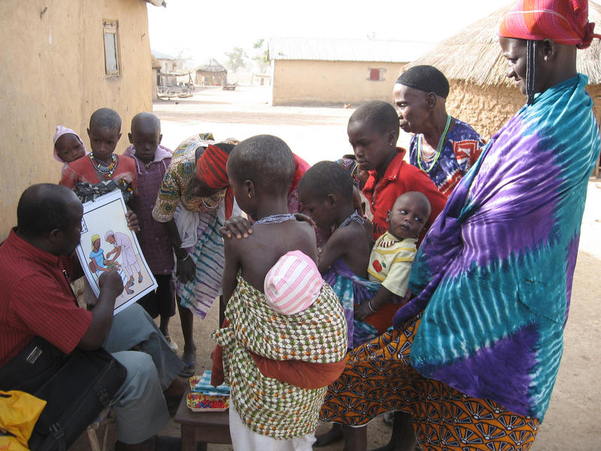
While at least a primary school educational level is usually desirable, the point is well made that in some roles and contexts illiterate CHWs have shown they can work as well as literate ones. Likewise, experience has shown that CHWs of a higher educational level than the communities they serve may not work well. The issues of how long training should be, where it should occur, and how it should be scheduled are discussed and illustrated by an extensive tabulation of training programs from different countries for different types of workers.
At a Peulh camp outside of Bagou, Benin, community health center head Nondichao Sahadou gives a health presentation to mothers and children about the importance of vaccinations. Following the presentation, Sahadou distributed vitamin A and deworming medication to children under the age of 5.
© 2006 Rebecca Mrljak, Courtesy of Photoshare

Good preparation and ongoing development of the trainers of CHWs are presented as essential. Many trainers of CHWs at the health facility, provincial, and district levels have been trained through traditional rote approaches. Therefore, adequate training in competency-based approaches with ongoing mentoring from a cadre of master trainers is an important part of CHW training programs. Standards-based approaches, including accreditation of training institutions, are needed to maintain the quality of teaching.
Who should be responsible for the governance and management of the training program?
It is important to clarify which organization is responsible for the governance and management of CHW training. For new programs, it is recommended that both a steering committee and an ad hoc or formal technical advisory committee be established. Key characteristics of these committees are presented through examples.
How can optimal performance be achieved through training?
This section discusses the different types of training that CHWs need to perform their tasks properly. While the quality of training and the regularity of refresher trainings are important for effective performance, other factors influencing CHW performance also need to be addressed. Chapter Nine presents factors that effective programs need to address as appropriate to each local context. Tasks that each CHW needs to perform are presented in the CHW Reference Guide’s Chapter Seven: CHW Roles and Tasks. Once a thorough analysis of each task has been undertaken, the combination of skills that make up each task – whether psychomotor, communication, or decision-making – can be identified, performance protocols and training curricula developed, and the particular learning needed for any or all of these three skill areas provided. Since CHWs need to perform specific tasks well, competency training based on a combination of skills from all three areas, rather than traditional knowledge-based curricula, should be used for most CHW training.
While the three types of skills require different types of learning, all require active participation of the trainee in the learning experience if competency is to be achieved. The different types of learning required for each of these skills are presented in some detail with good practical examples for each from programs in several countries. Of particular note is that when dealing with community beliefs and norms, community-oriented rather than individual-oriented communication approaches are needed. The use of appropriate teaching aides – such as pictures, photographs or videos, depending on different local circumstances – is also well presented. Appropriate attitudes towards patients are a key part of CHW learning; supporting CHWs to adopt supportive attitudes is well covered.
The focus of CHW training is achieving competency in performing particular tasks. Therefore, only evaluation of student competency by observation of their performance of these tasks is a valid assessment of CHW performance. Usually this assessment is taken using a checklist of the essential components of that task. Mastery of skills is a gradual process that requires ongoing practice and assessment. Maintenance of skills at a particular standard of competency requires regular refresher training and assessment. Therefore, follow-up monitoring and refresher training are essential to maintain the competency of CHWs. Remembering most CHWs are adults, I would have liked to see more emphasis on ongoing CHW input into course content and peer evaluation.
The different components of CHW training are brought together in the final section of this chapter. This section focuses on fitting the training to the situation in which the CHW will work. Training is a necessary but not sufficient basis for successful CHW programs. Key factors which need to be considered in adopting a particular type of CHW training are discussed and the characteristics of an effective training program for CHWs are summarized.
Chapter Nine originally written by Iain Aitken, MD, MPH

Chapter Ten: Supervision of Community Health Workers
Summarized by Kate Tulenko, MD, MPH
Chapter Ten of the CHW Reference Guide (Crigler, Gergen, and Perry) explores the critical and complex issue of the supervision of CHWs. Supervision of CHWs is a core health systems function that is often poorly understood and undervalued. Supervision is often incorrectly viewed as policing or as an unnecessary expense, but as this chapter shows, when supervision is properly designed and implemented, it can yield significant rewards in terms of quality of care, productivity, and retention of health workers.
As a synthesis of the current literature on supervision of CHWs, the chapter presents a series of strong takeaways that can be applied to CHW programs in almost any setting. Solutions are offered to the most stubborn challenges of CHW supervision, including budgeting, travel, and overburdened and poorly prepared supervisors. The chapter presents an incredibly helpful list of key questions to ask when designing supervision systems for health workers. If all CHW programs would consider these questions, we’d see a significant improvement in the quality of supervision.
The chapter explores the three main objectives of supervising CHWs: improve the quality of services, exchange information, and create a supportive work environment for the CHW. It also explains how both the community and the health system have a role in the supervision of CHWs. The need for supervision standards, guidelines, and job aids is discussed, as well as how to use information to improve CHW performance.
Different models of CHW supervision are explored, including facility-based supervision, direct supervision in the community, group supervision, peer supervision, and community supervision. The chapter includes a discussion of the promise of mHealth supervision (the supervision of CHWs via mobile devices). Where transportation remains a chronic problem either due to issues of budget, lack of functioning vehicles, or road conditions, mobile phone supervision or the use of professional transport companies should be considered.
In addition to enabling CHWs to interact with their supervisors more often, mobile phones open up the possibility of remote viewing of data, ePayment, and more. New mobile phone applications such as mHero can be used for systemic two-way SMS communication with health workers both during emergencies and routine work. In addition to exchanging data, these systems can be used to assess the mental health and motivation levels of health workers remotely. Such mobile phone applications, which can be made interoperable with the rest of the health system, can integrate supervision into larger data exchange and communications systems, allowing greater coordination and deeper analysis. Interactive Voice Response for distance learning on standard mobile phones can also push out new information when guidelines are updated as well as during epidemics. Hotlines can be set up for “just in time” supervision or technical assistance for CHWs.
Finally, the chapter ends with a discussion of finding the time for supervision. To avoid overwhelming supervisors with too many duties, space must be made in a supervisor’s schedule for effective supervision. This can be accomplished through a variety of means, including through dedicated supervisors who do not have clinical responsibilities or through eliminating the burden of travel on the supervisor by bringing groups of supervisees to the supervisor’s work site. The chapter ends with sample supervision checklists and documentation.
An ophthalmic clinical officer observes a community health worker examining a patient's eyes so that he can offer helpful feedback and support, if needed.
Photo credit: Hillary Rono, 2014
There is still much to be done in the field of supervision, many innovations to be tested and challenges to be explored. Supervision competencies (how to get the most of supervisory visits and how to work as a supervisor or peer supervisor) need to be integrated into the pre-service education of CHWs. Supervisors must be trained in how to supervise and in many cases supervisees need to be trained in how to use constructive feedback. In many settings, workers may never have received feedback before and may react to constructive criticism by shutting down or becoming demotivated. CHW supervision will benefit from the push to professionalize CHWs. As CHWs become standardized at the national level and professional associations, standards of care, and methods to remove negligent and unqualified CHWs are established, their supervision will also be standardized and elevated, as it has with higher level workers. These higher-level workers can also benefit from the lessons learned from CHW supervision. The reality is that many mid- and high-level health workers are not adequately supervised and what is learned from cost-effective supervision of CHWs can be applied to mid-and high-level health workers to improve their work experience as well.
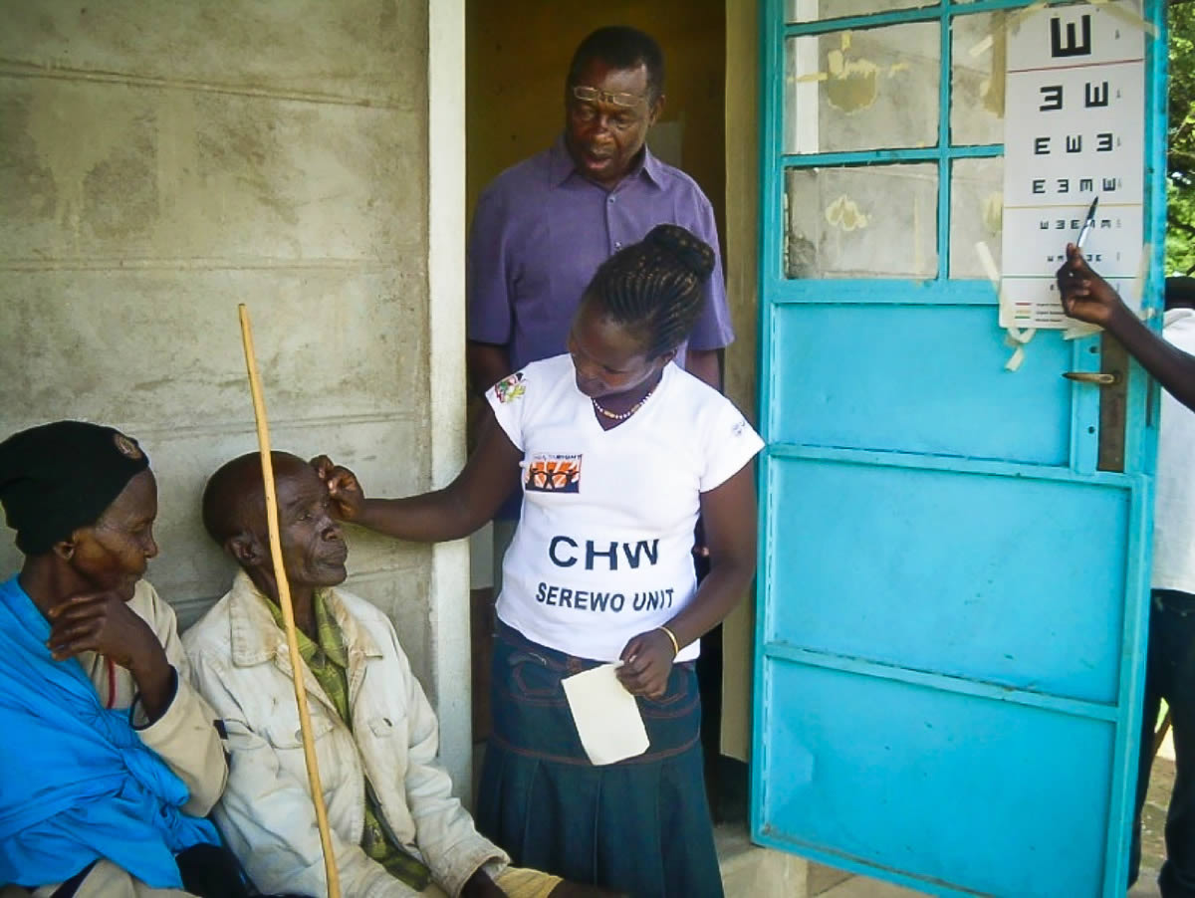
As the global health community looks toward Sustainable Development Goals and Universal Health Coverage, supervision needs to be seen as an essential input which leverages the existing resources in communities, including individual CHWs, their peers, higher level cadres, and the community. Supervision can play an important role in health systems resiliency. Most models of health systems resiliency emphasize the importance of communications and local capacity. When formal communications are interrupted by emergencies, the informal communications between supervisors and supervisees (especially via mobile phone) can serve as a key element of communication. In addition, peer supervision builds strong teams and robust capacity at the local level. This way, if communities are cut off from central governments in times of crisis, the peer supervision group can support one another to continue to provide their valuable services as well as respond directly to the emergency. The role of supervision of CHWs as a form of governance also needs greater recognition and exploration. CHWs are often the only formal representative of the central government in many communities.
Supervision is strongly linked to citizen voice and to women’s empowerment. When community members have a role in supervising their CHWs, they can—sometimes for the first time—have a say in the delivery of government service. Community involvement that starts in the health sector can then expand to other sectors so that communities are empowered to speak up about the quality of other crucial government and private services including education and transportation. In many societies, it may not be the custom for a woman to be “superior” to a man or to tell him what to do. Female supervisors supervising male CHWs may be the first time that some communities see a woman superior to a man at the local level. The existence of supervisory jobs also creates a career ladder for women to earn larger salaries and become more economically independent.
Ultimately, CHWs have special supervision needs. Their general level of education, literacy, and numeracy is usually much lower than other health workers and their period of formal CHW training is often less than a year. CHWs usually practice alone and are required to reach out to families, many of whom may not want their help and may disparage them as not being real health workers. This isolation, stress, and low level of skills can result in high levels of burnout, absenteeism, and attrition. We hope that by investing in high-quality supervision for CHWs that we can help them reach their full potential and help communities achieve optimum health.
Chapter Ten originally written by Lauren Crigler, MA, Jessica Gergen, MSPH, and Henry Perry, MD

Chapter Eleven: What Motivates Community Health Workers? Designing Programs that Incentivize Community Health Worker Performance and Retention
Summarized by Rebecca Furth, PhD
Policy makers, program managers, and donors are frequently preoccupied by the question of what incentives to provide CHWs to keep them motivated and performing. It’s no wonder, as many workers need compensation to do their work and incentives can have major implications for program costs and sustainability. Experience shows that lack of or inappropriate incentives are a common problem in CHW programs that frequently contribute to demotivation and turnover. However, the answer to the question, “What is the right amount to provide CHWs?” is not an easy one.
The reality, as Christopher Colvin points out in his chapter “What Motivates Community Health Workers? Designing Programs that Incentivize Community Health Worker Performance and Retention,” is that no one incentive or incentive amount will fit every context, nor can incentives remain static over time and still sustain CHW motivation. Instead, this chapter makes the case for a broad conceptualization of incentives, inclusive approaches for determining incentives, and systematic processes for monitoring, evaluating, adjusting, and sustaining incentives. It addresses two key questions: What forms of incentives are there; and what are the decisions related to incentives that must be made?
Direct incentives- Both financial and non-financial incentives
Financial: Salary, pension, insurance or performance payments.
Non-financial: Role clarity, supportive supervision, formal and informal recognition, and professional development (non-financial).
Indirect incentives - Health system and community elements
Health system: Effective system management, timely and regular payment, safe environment, job security, trust, transparency, and fairness.
Community: Community involvement, the support of community-based organizations and observable improvements in community health.
Complementary incentives - Policy and legislation that support CHWs, funding for CHW activities, support of CHWs by health care workers, appreciation or gratitude of community members, successful referral and CHW associations.

The chapter defines incentives broadly as “all those factors that affect the motivation of CHWs” and notes that “there is no easy, one-to-one relationship between incentives, motivation and practice.” To help navigate the complex terrain of incentives and motivation, it provides a useful framework that outlines three principal categories of incentives: direct incentives, indirect incentives and complementary/demand-side incentives. The case study of diverse community health workers in India is presented to illustrate both the range of incentives that may be used, even in a single country, and some of the challenges or pitfalls of incentives, including unintended negative consequences along with positive results.
A broad perspective of incentives and systemized approaches to incentive management are needed to guide national decision-makers in establishing effective incentive schemes that increase or sustain motivation and performance. Colvin notes that “Like any other aspect of the health system, incentives need to be 1) properly designed through review of the evidence and consultation with stakeholders, 2) implemented, managed, and monitored on an ongoing basis and finally, 3) evaluated to assess their effectiveness and plan for changes.”
With regard to financial and non-financial incentives, the chapter stresses that these are not an either-or, but a continuum of often complex offerings. When designing incentives schemes, policymakers and program managers need to consider a number of factors from local precedents and expectations to fairness and labor market factors.
Indirect and complementary incentives need to be considered in tandem with direct incentives. Key questions policymakers and program managers need to deliberate include: clear CHW roles, responsibilities, and feedback; personal growth and professional development; day-to-day working relationships; accountability in the health system and community; CHW “champions;” the role of civil society partners; and the community’s relationship to the health system and government.
Finally, putting in place plans to monitor, evaluate, and modify incentives over time is a critical step that policymakers and program managers need to consider from the start. Colvin remarks that “there is much more attention paid and evidence available with respect to the initial design of incentive packages, and much less is known about how to effectively manage and adjust these packages over time. In many cases, it appears that, once instituted, incentive packages either do not change or they change due to external circumstances (e.g. loss of funding) rather than a planned process.” To address this gap, the chapter stresses that management of incentives needs to be included in the design process and views and expectations of CHWs need to be integrated into this process. The key question, Colvin stresses, “is not what kinds of incentives will last the longest over time, but what kind of local process for designing, managing, and re-evaluating incentives will be most effective at responding to changes over time.”
Policy makers, program managers, donors, and others will find in this chapter valuable tables that frame the major questions that need to be considered when designing and managing incentives for CHWs. The most salient learning points to take away from the chapter are that incentives need to be tailored to the context; financial incentives are only one type of incentive, and planners should consider the whole range of direct, indirect, and complementary incentives when designing programs; and that planning needs to incorporate not just the incentive, but processes for monitoring, evaluating and adjusting incentives over time.
Chapter Eleven originally written by Christopher J. Colvin

Chapter Twelve: Community Health Worker Relationships with Other Parts of the Health System
Summarized by Allison Annette Foster, MA
Chapter Twelve of the CHW Reference Guide (Perry, Hodgins, Crigler, and LeBan) widens the lens of previous chapters to consider the CHW in the context of the health system. Chapter Twelve advises national governments and stakeholders to plan in advance before scaling a CHW program to clearly define the health need the program will answer, the role that the CHW program will play in addressing that need, the resources required to sustain that role, and the support systems necessary to enable the success of the program. First, this chapter links the roles that CHWs play to the building blocks of the health system, highlighting the correlation between the functionality of the system and the effectiveness of the CHWs. Second, the chapter explores the relationship between the CHWs and other actors in the system, describing the support that is required from each of those groups, including community members, other primary care providers, and decision-makers. Finally, the chapter explores several models for integrating CHW programs into community health systems. The chapter argues that CHWs can play a significant role in improving the health system’s ability to deliver care and services, particularly in low-resourced areas, but that this can only be achieved through 1) a functioning health system; 2) the support of actors within the system; and 3) a defined and recognized role for CHWs as an integral part of the primary health care (PHC) service delivery structure.
An effective CHW program depends on the support of a functioning health system
The chapter points out that gaps or weaknesses in the system will impede CHW performance and weaken the effectiveness of the CHW program. For example, if the CHW’s role is to distribute medications, such as misoprostol or antibiotics, then the CHW is in a position to contribute significantly to maternal and child health; however, she can only be successful if the health system’s supply chain consistently delivers the medications. In the role of health promoter, the CHW may be tasked to refer patients to the health facility and follow up with them afterwards. In this case, the CHW program may contribute to increases in facility utilization and improvements in antenatal care and post-natal services, but only if the information flow between facilities and CHWs is standardized, adequate, and reliable. Comprehensive health workforce policies are also important, providing clear job descriptions, adequate remuneration, and mechanisms for recognition so that the CHWs will be motivated and confident to carry out their roles.
A well-performing CHW program depends on support from other actors within the health system
For the CHW program to successfully integrate into the national health system and effectively enhance the services that the system provides, the program must have the political support of decision-makers, the respect and cooperation of other frontline providers, and the trust and confidence of the community. Policy- and decision-makers play a pivotal role in the success of the CHW program by clearly defining the specific need the CHW program will fill and planning adequate resources for recruitment, training, remuneration, supervision, management, and supplies. Support from providers is equally important to enable respectful cooperation and task sharing between facility teams and CHWs. Community support is critical so that community members will engage with CHWs in preventative and promotional activities for the improved health of their families.
Various approaches have been used to integrate CHW programs into the national health system
The chapter points out some particular strengths and challenges experienced in several of these approaches. The chapter describes, among other models: 1) the peripheral facility team model used in Peru, where a small outpost team is led by a nurse or midwife; 2) the Care Group Model, currently being scaled nationally in Burundi, where groups of volunteers are led by a promoter; 3) the Community-Directed Intervention (CDI) model, used in several countries, where CHWs help communities address specific diseases; and 4) the NGO management model with the example of BRAC in Bangladesh.
Reflections
Chapter Twelve is particularly important as government leaders and policy-makers apply the guidance of the previous chapters to their national demographic and epidemiologic contexts. Moving from a district-level or regional program or from a vertical-oriented project to a national program requires the cooperation of many actors. This chapter identifies those actors and provides several examples of how those actors may be engaged in the process of integrating the CHW program into the existing health system. The chapter also enumerates the requirements for a successful CHW program, explained in depth in earlier chapters, guiding decision-makers as they plan strategies and budget resources. Challenges that are mentioned in Chapter Twelve require thoughtful consideration:
- Functionality of the System: Health system building blocks necessary for the success of a CHW program are often weakest in the rural and low-resourced areas of the country, where the CHWs provide services. Therefore, scaling a CHW program needs to be part of a broader strategy to strengthen the entire community system, with benchmarks of improvement that may be correlated with the expansion of roles that the CHWs may play.
- Support of Actors: This chapter points out the disconnect between clinical professionals and CHWs. This gap should not be underestimated. The differences in education, culture, and even language create barriers between the facility-based providers and the CHWs and community health volunteers (CHVs). Further, concerns that CHWs and CHVs undermine the professionalism of nurses and midwives and threaten low-cost labor alternatives continue to weigh on attempts to integrate CHWs into frontline teams. It will be important that nurses, midwives, and physicians participate in defining roles and job descriptions of CHWs, and that they participate in the policy discussions on how the CHW program will align with and support the important roles of the existing frontline team members.
- Evidence: To maintain the support of health system actors, to sustain the allocation of necessary resources, and to continually monitor the needs and strengths of the CHW program, evidence will be essential. Often, collection and management of data at the community level is weak, inconsistent, and even inaccurate. In planning a national CHW program, policy leaders will need to invest in data management systems and in building competencies at all levels to collect, manage, and apply information. These competencies will provide the necessary evidence to make improvements, demonstrate impact, and advocate for resources to continue to strengthen the CHW program and the community health system.
Conclusion
A scaled CHW program offers governments the potential to expand and strengthen their national PHC services and ending preventable maternal and child deaths. Enabling CHWs to effectively contribute to these goals requires a shift in previous perceptions of the CHW program as a temporary stop-gap. Policy-makers and influential actors will need to consider the CHW program as an integral and seminal component of a functional PHC system at the first level. They will need to plan the development and management of that program as part of a broader effort to strengthen the building blocks of the health system, particularly at the community level. Moreover, it will be critical that communities, providers, and influencers are fully engaged in that process.
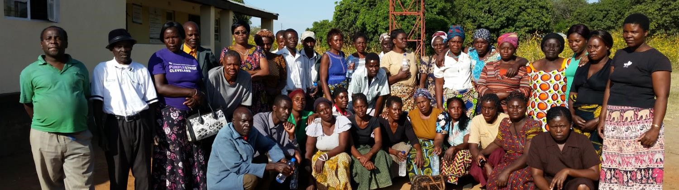
Community Based Volunteers support nurses at a rural health center. Photo provided by Allison Annette Foster.
Chapter Twelve originally written by Henry Perry, MD, Steve Hodgins, MD, MSc, DrPH, Lauren Crigler, MA, and Karen LeBan, MS

Chapter Thirteen: Community Participation in Large-Scale Community Health Worker Programs
Summarized by Maryse Kok, PhD
CHWs have an intermediary position between communities and the health sector, thereby improving access to health services for many people all over the world. This connecting position can also be challenging: on the one hand, CHWs are expected to conform to health sector guidance and performance targets, and on the other hand, they are embedded in and should respond to the communities’ needs and realities. Fostering the development of interpersonal, institutional, and community trust is therefore critical for effective CHW programs. Several studies have affirmed the importance of community participation in CHW programs since the Alma-Ata Declaration in 1978. For example, it can enhance utilization of services and community-based initiatives in health, and thus complement the role of CHWs in achieving universal health coverage.
Chapter Thirteen focuses on community participation in large-scale CHW programs. The authors, Karen LeBan, Henry Perry, Lauren Crigler and Chris Colvin discuss several key questions related to community participation and provide guidance for policy makers and program managers on what to take into account when developing and adjusting CHW programs.
Community participation: what does it look like?
Communities can participate in planning, supporting, and monitoring health services and CHW programs, though the extent to which communities participate in all phases of the program cycle and levels of participation can vary from sharing information to full responsibility. CHWs support community participation through sensitization and education efforts, as well as simply encouraging the community to participate in activities. Selecting CHWs, providing support to and incentives for CHWs, establishing community-based referral systems or insurance schemes, mobilizing community members or vulnerable groups, and holding health facilities accountable for quality of care are ways for communities to participate in CHW programs.
How to stimulate community participation?
- Designing CHW Programs to Enhance Trust
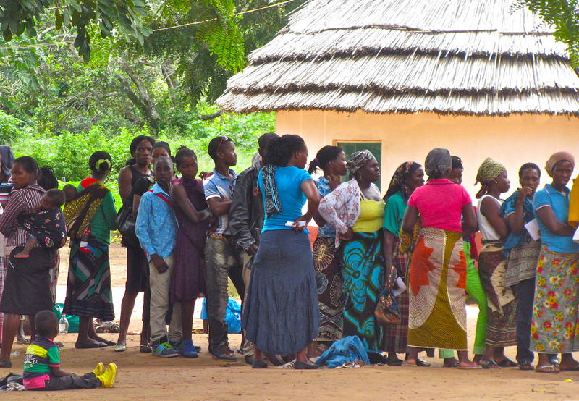
CHW programs should be designed to maximize trust among CHWs and their communities through CHW selection, role definition, training, supervision, and monitoring and evaluation. To ensure that selected CHWs are true representatives of the community and are capable of understanding the community, a wide variety of community members should be involved in the CHW selection process. Additionally, selection criteria should be carefully considered to avoid excluding particular groups. Furthermore, community trust can be enhanced by a formal introduction of CHWs and their tasks to the community with the assistance of local leaders. In some instances, communities create job descriptions and codes of conduct, which allows communities to tailor the CHW’s role to their needs. During CHW training, CHW-community relationships can be further enhanced by emphasizing soft skills such as empathy, listening, and expressing care. While uncommon, joint training of CHWs and selected community members has the potential to inspire community participation. Communities, often in the form of village health committees, can also have a role in supervision, monitoring and evaluation, and providing incentives for CHWs. These community-side support mechanisms need to be complementary to the existing structures in the health sector as successful joint efforts are proven to enhance CHW motivation and performance.
Community members waiting for services outside a health center in Mozambique. © 2014 VillageReach, Courtesy of Photoshare.
The above-mentioned program elements vary in different contexts according to the desired health outcomes of the CHW program, the capacity of the community, and the degree to which the cultural context is supportive. The authors provide an example of a CHW program in Honduras, in which teams of CHWs took ownership over their communities’ health. This involved CHW specialization, flexibility in operationalizing tasks, and providing rewards and incentives. This had a positive effect on community participation.
External factors, such as lack of resources, disinterest in community voices, and ambiguity regarding forms of governance, are harder to influence and can have a negative influence on community participation. Policy makers and program managers should take these external factors into account and focus on internal program design factors that could enhance participation. The CHW Reference Guide presents an overview of barriers and enablers that should be taken into account.
- Design of community participation policies and strategies
A policy or guidance document that outlines principles of community engagement assists in budgeting for community participation and enhancing accountability. Such a policy should be developed with the involvement of government, NGOs, and civil society actors, as establishing buy-in and managing expectations at the national, district, and local levels are essential. Non-governmental and faith-based organizations often have a longstanding role in designing, implementing, and evaluating CHW and community participation programs which, together with other evidence bases, is advantageous for policy and strategy development. An abundance of vertical programs, however, should be avoided, as different CHW training, supervision, incentives, and monitoring systems can undermine a national CHW or community participation strategy.
- The role of community management structures
Community management structures, such as village health committees, provide support for CHWs by assisting in community mobilization and communication between the health sector and local administration. The performance of these committees depends, like that of CHWs, on the method of selecting volunteers, role definition, training, supervision, program performance evaluation, and incentives. In addition, contextual factors, such as the extent of decentralization of the health system and power and trust relationships within institutions and among people in the society at large, influence strategies for community management structures.
In conclusion, the authors of this chapter state that community participation is of critical importance for well-performing CHW programs. As every community is different and dynamic, there is no one-size-fits-all approach in designing, implementing, and evaluating community participation and elements of programs. In every context, partnerships, trust, and respect between actors at all levels in the health system are essential to enhance positive and sustainable contributions to community health.
Chapter Thirteen originally written by Karen LeBan, MS, Henry Perry, MD, Lauren Crigler, MA, and Chris Colvin, MA, PhD

Chapter Fourteen: Scaling Up and Maintaining Effective Large-Scale Community Health Worker Programs
Summarized by Emma Sacks, PhD
It’s all too common a problem in global health for a successful community pilot program with intensive support and investment to face a number of challenges in later phases when efforts are made to expand, replicate, or scale-up the program. While community health worker (CHW) programs may be relatively inexpensive for a small geographic area or over a short timeframe, there is often a lack of planning and resource commitment for the institutionalization and support for CHW programs at scale in the long term.
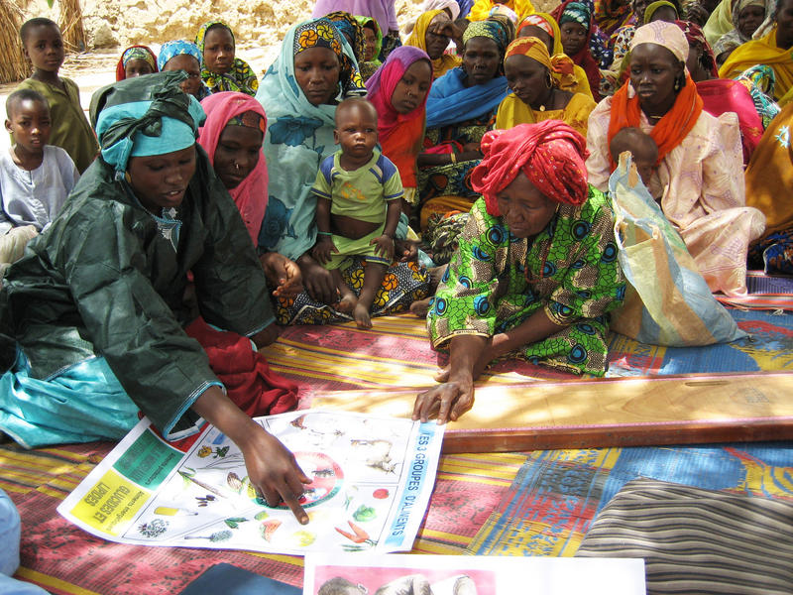
The CHW Reference Guide has a helpful chapter on “Scaling Up and Maintaining Large-Scale CHW Programs,” which highlights the importance of careful planning, ongoing monitoring with allowance for iteration and effective political engagement with multiple actors and stakeholders from the outset. The Guide makes the assumption that CHWs will be guiding the scale-up of a national CHW program, but does not go into detail about the various possibilities for managing multi-cadre systems, which may include coordination and regulation of both Ministry of Health-supported and NGO- or partner-supported CHW cadres.
Village volunteers in Diffa, Niger, speak with a mothers’ group about feeding their children foods rich in vitamin A.
© 2008 Marily Knieriemen, Courtesy of Photoshare

The Guide asks planners to consider what they expect the CHW program to look like, what type of planning is needed to reach scale, what potential pitfalls might be, and what contextual factors or external conditions are important for success. Key issues listed involve an early understanding of the complexity of the activity, an assessment of the local needs and capacity, knowledge of specific program requirements, a plan for ongoing monitoring and evaluation, and strategies for ensuring equitable coverage. Planners should also make realistic estimations of both start-up and recurring costs to maintain the program. If CHW programs are designed to be embedded within the national health system, planners and policymakers should map out the potential implications of the program on the existing health system, including the effects on managers and clinical staff both within and beyond the health sector.
Work-plans for CHW programs have to consider many stakeholders and a number of different procurement and management issues. These include supplies of medications and equipment, human resources, supervision and accountability structures, legal and regulatory issues, and quality assurance processes. Programmers also must consider the most strategic way forward for scale up. It might be through horizontal expansion, which aims to increase the number of beneficiaries receiving the same services, which can occur through additive replication or multiplicative growth. Programmers can also consider vertical expansion, which aims to institutionalize the program through high-level policies that need to be in place prior to project roll-out, which may take longer to set up but are more likely to be sustained. CHW programs can also grow through diversification, where tasks or services are added to current CHW responsibilities, although this carries a risk of reducing the caseload any given CHW can then cover. Efforts to be realistic and rational about the types of expansion desired during the planning phase can have larger positive impacts on programs in the long-term.
The Guide also warns against common challenges to scale up such as lack of coordination among partners, conflicts over the use of current vs. new cadres of CHWs, the promotion of un-scalable pilots, underestimation of budgets or long-term costs, failure to understand the complexity of the interventions, too rapid a pace of geographic spread, poor quality training and supervision of CHWs, lack of codified CHW competencies, and poor adherence to and regulation of basic clinical standards. Envisioning the scale-up process merely as a training cascade generally will not produce desired results, because the needed support systems for different levels of CHWs will not be in place. Ultimately, national CHW programs are most often doomed by the fact that they were scaled-up without a plan or the allocated resources for sustainability over at least a decade.
In order to sustain impact at scale and program momentum, the CHW program needs to be a priority even after the initial scale up phase. One recommendation for keeping the CHW a priority within the Ministry of Health is to set up a Technical Working Group with regular meetings and a diverse membership that is committed both to the process and the outcomes. In order to sustain impact, services must stay relevant and accessible and the quality of services must be continually high. Recent research shows that to stay motivated, CHWs desire fair and timely pay, respect from peers and supervisors, and opportunities for professional advancement.
The Guide presents two conceptual frameworks widely promoted for scale up: the ExpandNet/WHO Framework and the Management Systems International (MSI) framework. ExpandNet comprises five components and seven attributes thought to be necessary. This model asks the user to consider if there are ways to simplify the innovation or service while retaining the essential components. This streamlines the scale up process while ensuring that the desired outcomes can be reached. The MSI model has three steps and focuses on adapting projects to the local system to reduce reliance on unpredictable donor funds.
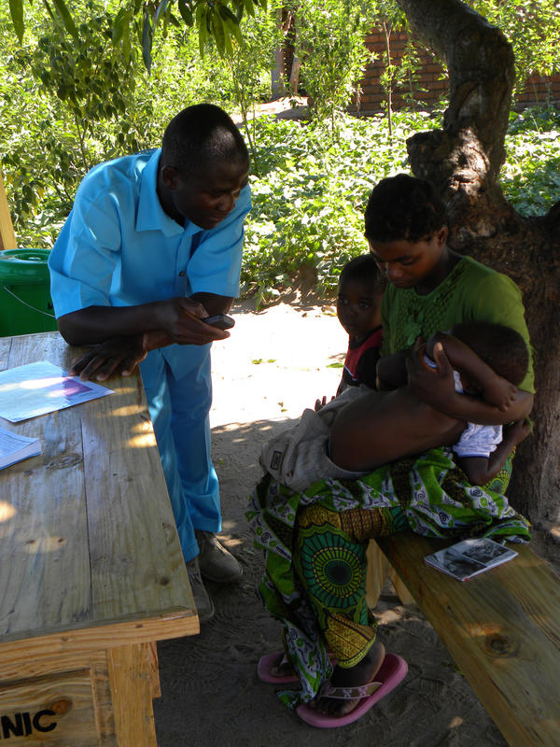
Many organizations focus on the parts of a health intervention that can be controlled, but the environment and local context can greatly influence the success of a scale up effort, as well as the choice and pace of strategies. Understanding the political and donor environment can help policymakers choose between phased vs. rapid approaches and focused vs. integrated packages of interventions. Taking advantage of politically opportune moments must be balanced against the long-term goals and realities of the project.
The Guide defines three important contextual factors to consider:
- local epidemiology, demographics and burden of disease;
- the current mix, density and coverage of primary health care services and public-private mix of providers; and
- the current strengths and weaknesses of the local health system, including governance, finance and sustainability.
In order to effectively scale-up CHW programs, a number of elements must be in place: strong leadership, fit to the local context, long-term financial investment, and continual monitoring and improvement. Most importantly, planning from the beginning is needed, which takes into account the needs and expectations of beneficiaries, and the projected impact on health outcomes. As CHWs expand from largely rural programs to national ones, lessons can be learned from efforts in many countries. The Guide provides examples of scaled-up of CHW programs from India, Brazil, China, and Bangladesh. Newer examples are also now emerging from Ethiopia and Malawi, as governments work on equipping, expanding, and standardizing cadres of CHWs and embedding them into the national health system. Monitoring and evaluation systems should be built into programs, and opportunities for iteration and adjustment allowed to continually improve, strengthen, and grow CHW programs.
A community health worker at a village clinic in Balaka District, Malawi, looks for fast breathing in a child using his phone to time the counting.
© 2010 Leah Hasselback, Courtesy of Photoshare

Chapter Fourteen originally written by Steve Hodgins, MD, MSc, DrPH, Lauren Crigler, MA, Simon Lewin, MBChB, MSc, PhD, Sharon Tsui, MPH, PhD, and Henry Perry, MD

Chapter Fifteen: Measurement and Data Use for Services Provided by Community Health Workers
Summarized by Jen McCutcheon, Msc, MPH, DrPH
In this chapter, the authors introduce the concept of program measurement as having three main purposes. The first is to use data to help define or identify a problem needing attention or intervention. For example, data from health facility registers may indicate that utilization of a specific service is low (e.g., immunization or delivery with a skilled birth attendant). Based on these and other available data that can help refine the nature of the problem, program implementers may design an intervention to address the problem. The second measurement use described is program evaluation, aimed at determining the effectiveness of a program. These studies may be done by the program implementers, or by an external group. Evaluations generally have some degree of separation from the programmatic work, and are used more to inform the public health community about what does and does not work than to improve functioning on the existing program. While donors such as USAID and others are placing much greater emphasis on evaluations,1 the field still faces significant challenges that include: a lack of baseline data to compare endline evaluation data to project life spans that are too short to measure significant changes in impact; and numerous extraneous factors that either positively or negatively impact the success of the project.
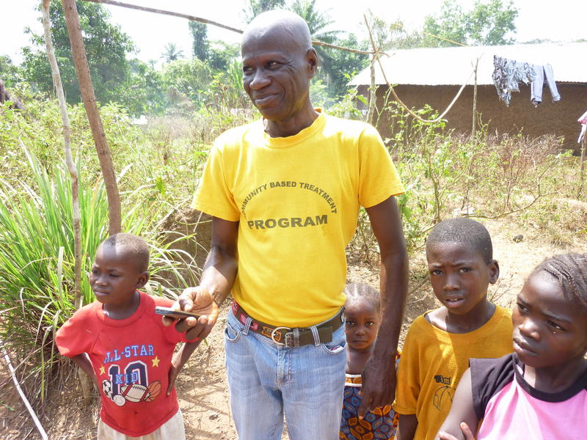
Finally, the authors describe the most common use of data in CHW (and other public health) programming, routine monitoring. Monitoring data generally come from existing sources, such as health records which are aggregated up the system through the government’s health management information system (HMIS); programming or training records; or supportive supervision visits. The most effective monitoring systems are those where the data are routinely shared through simple graphs and reports and discussed regularly by program staff and managers. The authors reference “structural experiential learning” to describe this rigorous, real-time tracking of important aspects of the program, with tight feedback loops and continuous use of data to improve programming.
A community health worker in rural Sierra Leone uses a mobile phone to track health status of children under 5 years of age.
© 2012 Paul Amendola/IRC, Courtesy of Photoshare

Existing data sources such as client registries or training records provide valuable information about number of services delivered or utilized by targeted populations. In countries where these registers exist, starting a monitoring and evaluation (M&E) system by routinely tracking and using these data can be a useful and achievable first step. However, these data sources are not able to answer important questions about the quality of the services provided, or changes in knowledge, attitude and practice (KAP) of either target populations (e.g., did they change their behaviors based on the messages given by CHWs?), or of the providers (e.g., what influences morale or motivation for CHWs? Has the practice of CHWs changed based on a training that was given?). Finding answers to these questions will help to show the quality and the impact of the project and are therefore important components of a CHW M&E system, yet they are also more time consuming, costly, and often methodologically difficult. Care needs to be taken to prioritize the questions and the methods that will enable program staff to answer key questions within a realistic timeframe, scope and budget.
Hodgins et al approach M&E system development with suggested steps to respond to three key questions/scenarios:
- Are the important elements of community health services being measured? If not, what is the minimum information that the manager needs to have to know what is actually happening? What is the simplest way that this information can be collected?
- Are the data that are being collected being used to identity and address performance issues? If not, focus on creating a culture of data use: build capacity of staff, health workers, and supervisors to conduct simple analysis; discuss data findings in regular staff or facility meetings.
- Are there multiple or confusing data collection forms/registers that result in poor quality data (i.e., incomplete, inaccurate)? If so, then bring key technical staff together to streamline and simplify data collection forms, focusing only on key data that are most important for regular use.
The chapter ends with case studies that provide examples of data collection, monitoring, and evaluation in Ethiopia, India and Pakistan CHW programs.

Additional Considerations
M&E Budget Allocation
Unless an evaluation is conducted by a separate group (as some donors are doing more frequently), the costs for program monitoring and evaluation come from the same “pot” of money as the program costs. Therefore, a balance must be struck where the maximum amount of funds is given to program costs, while still maintaining adequate funds to monitor the program enough to identify and address issues as they arise. The percent of a program budget that is allocated to monitoring and evaluation activities is recommended to be between 3 and 10 percent of the program budget.
Demystifying the Analysis of Monitoring Data
The words “data analysis” can scare some program implementers, as visions of logistical regression classes flash through their minds. However, analysis of program monitoring data should generally be kept simple. Most basic monitoring data that is used for assessing the progress of a program falls into one of three types of analysis: against a target, across groups, and over time. A few examples include:
- data often compared against a predetermined target such as aiming to train 500 CHWs this year;
- data comparisons across groups or geographic areas within the project (e.g., across districts), or
- data compared over time (trend analysis over each month of the project, or comparing this June compared with last June).
Additional questions to consider when designing an M&E system for CHW programs:
Who is providing the services and who is receiving the services? What methods are most efficient to collect data from these individuals?
What services are being provided by the CHWs, what gaps are they addressing (and what gaps still exist)? How can data be collected on a) the services provided, and b) the quality of the services provided. Measuring quality can be more resource intensive, so consider doing quality checks on just a sample of the services through direct observation or supportive supervision, or client exit interviews.
Where are services being provided? community vs facility, how are the community and facility services linked? How can improvements in those linkages be measured/documented?

A sampling of data collection methods used for CHW programs:
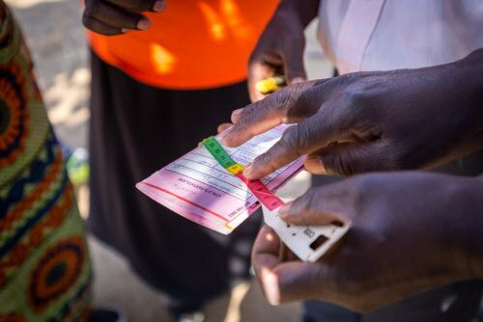
This list of methodologies for CHW programs is by no means exhaustive. It is meant to provide a variety of (reasonably) easy to implement options for CHW Program implementers.
- Client records: wherever possible, linked to existing HMIS, or at least coordinated with other implementing partners and in collaboration with local officials
- Supportive supervision: wherever possible, in collaboration with facility staff and/or local officials
- Client exit interviews or satisfaction surveys: short surveys asked to a sample of clients about their level of knowledge after a visit and/or their satisfaction with the services that were provided
- Direct observation of services provided: even systematically observing a small sample of CHWs or services can provide valuable information and help improve quality
- Community/facility level quality improvement cycles that include ongoing data collection and use
- Qualitative methods such as focus group discussions or interviews with key stakeholders
- Mapping of services available or provided in a community (and using the map data for decision making, resource allocation, and tracking change over time)
Given the disconnect in some countries between the work conducted by CHWs and the data in national HMIS, M&E can be particularly challenging for CHW programs. Starting from an end use perspective: “what questions do we want to answer with our data?” can help focus the M&E system development on aspects most critical to designing programs that address real needs, monitoring the implementation and quality of programs, making adaptations based on the monitoring data, and evaluating the effectiveness of CHW programs.
Chapter Fifteen originally written by Steve Hodgins, MD, MSc, DrPH, Dena Javadi, MS, and Henry Perry, MD

Chapter Sixteen: Wrap-Up: Case studies of large-scale community health worker programs: examples from Afghanistan, Bangladesh Brazil, Ethiopia, India, Indonesia, Iran, Nepal, Pakistan, Rwanda, Zambia and Zimbabwe.
Summarized by Polly Walker, PhD
The CHW Reference Guide’s Appendix A covers cases studies produced under the Maternal and Child Health Integrated Program, the United States Agency for International Development Bureau for Global Health’s flagship maternal, neonatal and child health project.
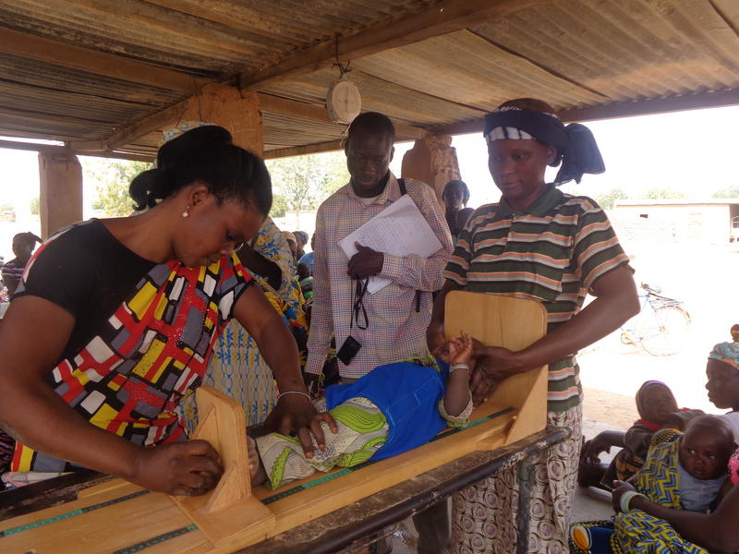
Appendix A of the CHW Reference Guide provides an in-depth view of 13 large-scale CHW programs drawn from diverse settings. The programs are mostly government/public-sector, but notably include one large-scale NGO program, Bangladesh Rural Advancement Committee (BRAC), which currently supports over 100,000 CHWs globally. Many of these programs have been mentioned throughout the guide already. However, in the case studies they are viewed within their historical and policy contexts and their integration within the health system, with an exploration of challenges and successes provided by key informants. Each study is structured in the same way– addressing most of the critical implementation points, how the CHWs are selected, trained, supervised, and deployed in each system, as well as the role they take in the formal health sector and in community engagement. The collection presents insight into how CHW programs have evolved in diverse regions including South America, Africa, Asia, and the Middle East since Alma Ata to the end of the MDG era.
A community health workers measures a child during a growth monitoring and promotion (GMP) session at a health post in the health district of Tougan in Burkina Faso.
© 2015 Amelie Sow-Dia, Courtesy of Photoshare

In reading these studies, several key concepts emerge. Firstly, there is an extraordinary diversity of the ways in which CHWs are being engaged across the globe and in different development settings. Many programs have been evolving for more than 20 years and aiming to meet the changing health needs of their populations. Even now, many policy-makers in low-middle income countries consider CHWs as a ‘band-aid’ for failing health systems, and simply a stop-gap until the real aim of building skilled health-workforces can be achieved. In the country programs described here, you will see, this idea really isn’t evidenced. The roles and tasks that CHWs play in health system strengthening have in fact expanded, rather than being diminished through economic development. They have become increasingly recognised as a major component of effective national health strategies, and their importance has in no way been devalued as the formal health workforce expands.
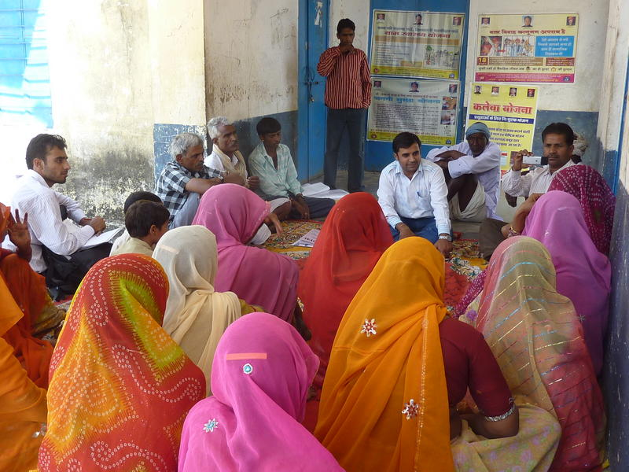
Most of the studies describe programs that started from small beginnings in the late 1980s or early 1990s, with CHWs focused on health promotion and treatment of childhood diseases, aimed at quickly reducing preventable child deaths. As programs have grown in size they’ve also expanded in scope and complexity of services provided to include services with higher level competencies such as HIV and TB care, family planning, immunizations, injectable contraception, and newborn care. Typically, only the long-running successful programs have been able to include components such as distribution of misoprostol and chlorhexidine distribution, and management of newborn infections using injectable antibiotics (e.g. Nepal and BRAC). Several countries, such as Ethiopia and Rwanda, appear to have staggered the task-shifting of family planning provision to the CHW level once the program was well established, and in these cases, has led to a dramatic increase in access and coverage. In Brazil, the role of the CHW has evolved towards more of a rehabilitative and supportive role in the community with a focus on management and prevention of non-communicable diseases, reflecting the epidemiological shift. This emerging trend is also seen in India and Bangladesh. CHWs are able to provide community-level support and to target specific at-risk populations that health services may not otherwise reach, and therefore may well continue to be the cost-effective solution regardless of economic development of a country.
Health workers from a local NGO in Udaipur, Rajasthan, India, talk to village women about better health and care for their children..
© 2011 Geom Abraham, Courtesy of Photoshare

There is huge diversity in the history and financing of CHW programs. Most have been launched from pooled resources and multi-stakeholder initiatives driven by bilateral donors, World Bank, UNICEF and Global Fund and other NGOs, with government gradually taking over elements with domestic finance. However, in the most successful programs it’s been about how well the government has used donor finance towards building a comprehensive system than the contributions of donors alone. Most countries, with the exception of Brazil and Iran, are sustained by a combination of donor, NGO, and domestic finance, and the national funds are often used to establish fixed salaries whilst partners support the program ‘software’, for example in Nepal, Zambia, India, and Pakistan. Many country programs that are less successful and have failed to reach scale are still fragmented by conflicting donor and NGO interests which have not been reconciled. Domestic finance through centralised funds or national health insurance schemes clearly emerge as an essential ingredient for successful scale.
Another key concept is that CHW program success factors have more in common than not, and remarkably, implementation challenges are practically universal. Common success factors include the consistent embedding of CHW programs in health systems, formal links with health services, and community engagement through health committees in which the role of the CHW is supported. There appears to have been a gradual shift towards incentive payments to salaries for a ‘low-level formalised cadre’, although with continuing roles for volunteers. Several countries have shifted towards multi-cadre systems involving a combination of formal low-level workers and community volunteers (Ethiopia Health Extension Workers and Health Development Army; Bangladesh national CHW program). There are cases in which the CHW programs have been very successful and yet have remained an unsalaried voluntary workforce. They’ve achieved this through building team-based approaches to share the workload (Rwanda, Afghanistan, Indonesia), providing collective support for income generation (Rwanda), and where community cohesion and embedding is very strong (Indonesia). Another common success factor is the link to gender empowerment: most CHWs are in fact women, typically with little more than a primary level education, but the CHW work enables both economic empowerment and enhances the respect for women’s contribution in the community. In the context of the BRAC program the switch from male to female CHW enhanced its sustainability, although in other settings a predominantly female workforce has led to increasing concern for their security, such as Afghanistan and Pakistan.
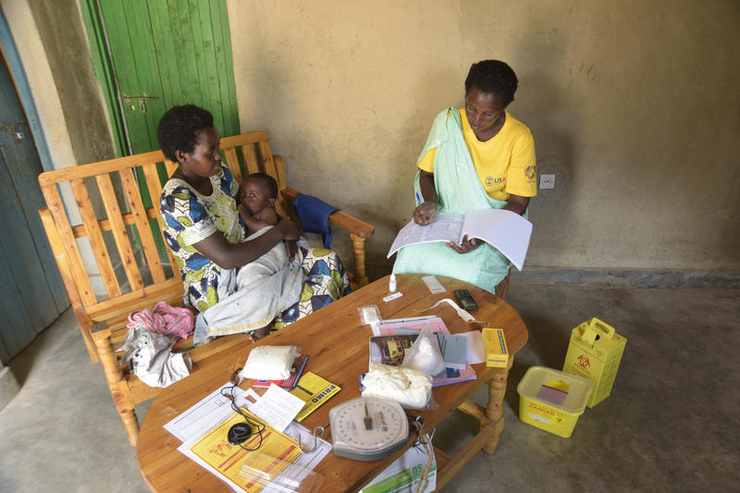
The common, almost universal challenges appear to include consistent remuneration whether incentives or a salary, ensuring CHWs reach isolated/marginalized communities and populations, sustaining commodities and supply chain, and providing regular supportive supervision. Some of these can be addressed through good integration with health systems, enabling the program to be sustained and effective. However, where health systems have themselves declined, been overly de-centralised or lack support, it is the CHW systems at the bottom of the food-chain that suffer the most. In the context of Zimbabwe where a successful VHW program had been scaled up, in the 1990s the economic downturn and political problems saw the VHW program diminish to less than 20 percent coverage which likely made a big contribution to the increases in child mortality. Pakistan, having established its well-known Lady Health Worker program over decades, having decentralised health administration completely to provincial level, has become increasingly varied in the functionality and mandate of the LHW workforce.
Conclusions: What works in large-scale programs? Here are the key take-home lessons from this extraordinary collection of case studies:
Community health worker member Ataria Mukamusoni of the Dufitintego cooperative in Nyanza, Rwanda, tests Fruit Irakoze, a 1-year-old sick child, for malaria while his mother Gemma Niyigena holds him in their home.
© 2017 Riccardo Gangale, Courtesy of Photoshare

- Recognise the need for this workforce independently of doctors and nurses. CHWs, with the right support and political leadership, can move epidemiological mountains at a fraction of the cost of medical training. Don’t think of them as a short-term fix - their roles can evolve to meet the changing needs of the demographic.
- Start small and build from the base, ensure government leadership especially in directing the utilisation of donor funds towards a strong core program, enshrined in a solid policy and five-year strategy.
- Envisage multiple cadres in a team approach, including potentially both voluntary and non-voluntary players.
- Create a cadre of supervisors; don’t deploy a CHW workforce expecting overburdened health staff to manage that role.
- Don’t decentralise the health system until you have a solid functional CHW program up and running; this will lead to further fragmentation of the community workforce, reducing cost effectiveness and wasting money on parallel planning and training exercises.
- Channel national insurance into providing basic commodities and supply chain strengthening, start getting creative and direct what you do have towards intelligent income generation and endowment funds.
Appendix A originally written by Henry Perry, MD, Rose Zulliger, MD, Kerry Scott, MSc, Dena Javadi, MS, Jessica Gergen, MSPH, Katharine Shelley, MPH, PhD, Lauren Crigler, MA, Iain Aitken, MD, MPH, Said Habib Arwal, MD, MA, Novia Afdhila, MPH, Yekoyesew Worku, Jon Rohde, MD, and Zayna Chowdhury, MPH, PhD

Perry, H, et al. (2014). Developing and Strengthening Community Health Worker Programs at Scale: A Reference Guide and Case Studies for Program Managers and Policymakers.
Perry HB, Zulliger R. "How Effective Are Community Health Workers? An Overview of Current Evidence with Recommendations for Strengthening Community Health Worker Programs to Accelerate Progress in Achieving the Health-Related Millennium Goals 2012," Johns Hopkins Bloomberg School of Public Health, September http://www.coregroup.org/storage/Program_Learning/Community_Health_Workers/review%20of%20chw%20effectiveness%20for%20mdgs-sept2012.pdf (accessed May 4, 2017).
El Arifeen S, Christou A, Reichenbach L, et al., "Community-based approaches and partnerships: innovations in health-service delivery in Bangladesh," Lancet (2013): 382(9909), 2012-26.
Houston R, Acharya B, Poudel D, et al., "Early initiation of community-based programmes in Nepal: a historic reflection," Journal of Nepal Health Research Council (2012): 10(21), 82-7.
Banteyerga H., "Ethiopia's health extension program: improving health through community involvement," MEDICC review (2011): 13(3), 46-9.
Olson DJ, Piller A., "Ethiopia: an emerging family planning success story," Stud Fam Plann (2013): 44(4), 445-59.
WHO, UNICEF, "Declaration of Alma-Ata: International Conference on Primary Health Care," September 6-12, 1978.http://www.who.int/publications/almaata_declaration_en.pdf (accessed May 4, 2017).
Commitment made at the 3rd Global Human Resources for Health Forum in 2013
Sachs, J. (2015, June 15). A Call to Scale-Up Community Health Workers. Retrieved from http://www.huffingtonpost.com/jeffrey-sachs/a-call-to-scale-up-commun_b_7584724.html
Addis Ababa Call to Action on a High-Level Ministerial Meeting on Investing Human Resources for Health for Sustainable Development, 17 July 2015.
USAID. (n.d.). ExpandNet & WHO Tools for Fostering Change for Scale-up. Retrieved June 02, 2017, from https://www.k4health.org/toolkits/fostering-change/expandnet-who-tools-fostering-change
Management Systems International. (2017, April 21). Scaling Up Development Innovations and Social Outcomes. Retrieved June 02, 2017, from http://www.msiworldwide.com/approach/tools/scaling-up-framework-toolkit/
1 USAID Evaluation Policy. (2011, January). Retrieved from: https://www.usaid.gov/evaluation/policy
Lant Pritchett, Salimah Samji, and Jeffrey Hammer. It‘s All About MeE: Using Structured Experiential Learning (“e”) to Crawl the Design Space. Retrieved from: http://www.cgdev.org/sites/default/files/its-all-about-mee_1.pdf
CRS and ARC. (2008, September). Shortcuts in Monitoring and Evaluation. Retrieved from: http://pdf.usaid.gov/pdf_docs/Pnadq477.pdf

